1. Data Processing What is Big Data? (L1)
   1. Data comes from IoT and sensors in addition to devices – volume is huge and is growing at a staggering rate from a variety of sources and formats
   2. Data processing = taking data and using a process to create information
   3. We need systems that can cope with Volume, velocity and variety of data – various:
      1. Relational DBMS either centralized or distributed = operational workload
      2. NoSQL[1] graph, document, key-value stores = unstructured data and highly available systems
      3. Hadoop, Spark = for analytics over massive scale data
2. Data Base = very large, integrated collection of data that models a real-World enterprise (L2)
   1. Needs data structures and algorithms (Database Management System – DBMS) and systems to allow:
      1. Storage of the data = safe haven
      2. Retrieval of the data via application
      3. Managing or manipulate the data including inserting new data
   2. Benefits: **memory_aid: DIndy-DA-DA-CA-DI-RAD**
      1. Data independence = user or application developer does not need to know anything about how the data is stored or organized inside database or performance or scalability issues – isolate the application user from database
      2. Efficient data access = if app developer does not have DBMS they need to take care of how to index the data or how to efficiently retrieve the data from how it is stored – but ordinarily the DBMS carries these burdens for the user
      3. Data Administration = one location for data and one portal for manager
      4. Concurrent access and crash recovery
      5. Data integrity and security = built into the DBMS
      6. Reduced app development time = DBMS allows developer to focus solely on the logic of their app not the workings of the database
3. Data Model = collection of concepts for describing data – Schema = description of data using model (L3)
   1. Relational model of data = most widely used model = a mathematical model
      1. Relation is shown through table instance with rows and columns, *i.e*. Tuples
         1. Each column or field represents an attribute
         2. Number of rows = **Cardinality** and number of fields or columns = **Degree** or **Arity**
   2. Levels of abstraction in data systems:
      1. Views or External schema is similar to conceptual schema but describes how users see the data – can have multiple external schemes in a database = **tuple listing each relations/field/column**
         1. Views are very memory efficient so you store a view rather than rerunning complex queries over and over – Internet and tutor disagree and say query and view = same speed, i.e. “A view is still a query, it just abstracts certain parts of it so that your queries can be simplified (if they do similar things) and to maximize reuse” (from Stackoverflow)
      2. Conceptual schema defines logical structure = logical representation of data (e.g. ER Diagram)
         1. aka Logical schema = ER Diagram or overall plan for database
      3. Physical schema describes the files and indexes used = physical storage of data

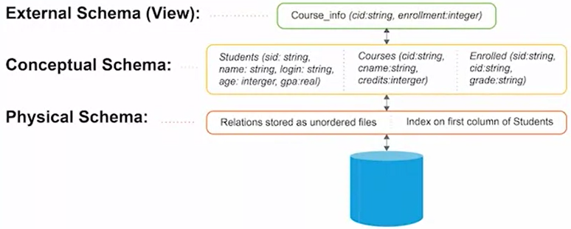

* 1. Data Independence for each schema
     1. Logical Data Independence = protects user/app from changes in logical structure of data
     2. Physical Data Independence = protects user/app from physical structure of data

1. Database Design – Entity Relationship (ER) model (L4) – ultimately converted to relational model
   1. Phase 1: Requirement Analysis
      1. What users/apps expect from the database
   2. Phase 2: Conceptual Database Design
      1. Build entity relationship diagram that represent relations of data
   3. Phase 3: Logical Database Design
      1. Convert entity relationship design into relational database schema
   4. ER Model basics:
      1. Entity = real-World object distinguishable from other objects and described by a set of attributes each of which has a type such as string or int [□ rectangle in chart and entities attributes are represented by an oval]
         1. Rectangle for Entity = table and ovals for attributes = columns
      2. Entity Set = a set of similar entities, e.g. and employee entity ⊆ entity set of employees
         1. All entities in entity set have same set of attributes
         2. Each entity set has a key that uniquely identifies the entity = primary key
         3. Each attribute has a domain of values it can contain
      3. Relationship = association among two or more entities [◊ diamond in chart] relationship says entity “does something” in/with another entity
         1. **Uniquely identified by the two entities it relates**
            1. This does not allow time dependent relationships as a relationship can only exist with two entities, *e.g*. if an employee entity works for a department entity only some of the time. Solution is to add a duration entity with from and to attributes thus creating a ternary relationship instead of just a binary relationship (see diagram in iv below)
         2. Key Constraints such as one entity can only be related to one other entity such as a department can only be managed by one employee even if one employee can manage many departments (***see* chart Departments 🡪 Manages**)
         3. Different types of key constraints:
            1. 1-to-1 (represented in ER diagram by an **arrow pointing from each entity** to the relationship showing each participates only one time and either can be null [thin line meaning foreign keys can be null]) – NOTE merging 2 entities into a single table occurs when 1-to-1 relationship has total participation i.e. the foreign keys are not allowed to be null
            2. 1-to-many **(mgr-to-dept below so arrowhead = the 1)** many-to-1
            3. Many-to-many = default aka m-to-m
         4. Participation Constraint – entity must participate at least once in relationship [**shown by dark line on chart**]
            1. **Means entity from which dark line starts must participate at least once in the relationship** (*e.g.* Dept. must have a manager or an employee must work in a dept as you cannot have a department without an employee working in it)
            2. This is called “**total participation**” whereas the default is “partial participation”
            3. Total participation requires a NOT NULL in the SQL code (shown by heavy line)

In ternary such as “works in” example you need additional check constraint as not null is not enough, and you need to make sure every employee has a works in relationship with a department

* + - 1. Weak Entity = depends on other, stronger entity (*see* benefit dependents depend on the employee entity diagram below)
         1. A foreign key must always be present in a weak entity
         2. Owner entity and weak entity set must participate in **one-to-many relationship (RAMA 36)** set (one owner entity is associated with one or more weak entities, but each weak entity has a single owner). This relationship set is called the identifying relationship set of the weak entity set.

Weak entity is connected to strong entity by a relationship

**(RAMA 36)** A weak entity can be identified uniquely only by considering some of its attributes in conjunction with the primary key of another entity, which is called the identifying owner.

Weak/dependent entity identified by partial key such as a serial number **(RAMA 36-7)** combined with a primary key of the strong entity e.g. the dependents for health insurance example (partial key shown by broken underline on ER Diagram, whereas primary key shown by underline)

ON DELETE CASCADE used in SQL code to form weak relationship

Total participation + one-to-one = weak relationship

**(RAMA 36)** The weak entity set must have total participation in the identifying relationship set.

* + - * 1. Weak entity set must have **full participation or total participation** in this identifying relationship set (signified by a bold line in ER Diagram and ON DELETE CASCADE code with no error raised but entity deleted automatically) but not all entities with full participation are weak entities (only must participate with ON DELETE NO ACTION code + error message with no deletion)
    1. Relationship set = collection of similar relationships

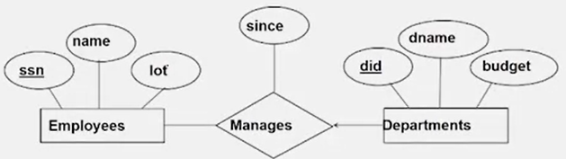

* + 1. Class Hierarchies – attributes are inherited via an “Is A” (ISA) relationship [**shown by ∆ triangle on chart**] **(see also page 6)** - this is like inheritance in object-oriented programming
       1. Use to add descriptive attributes specific to subclass
       2. Use to identify entities that participate in a relationship

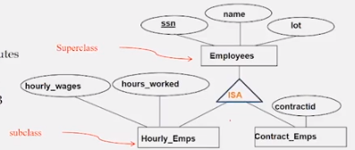

* + - 1. Overlap Constraints are either allowed or disallowed, e.g. an hourly employee can also be a contract employee
         1. **(RAMA 38)** Overlap constraints determine whether two subclasses are allowed to contain the same entity. For example, can Attishoo be both an Hourly_Emps entity and a Contrac_Emps entity? Intuitively, no. Can he be both a Contrac_Emps entity and a Senior_Emps entity? Intuitively, yes. We denote this by writing **'Contract_Emps OVERLAPS Senior_Emps**.' In the absence of such a statement, we assume by default that entity sets are constrained to have no overlap.
      2. Covering Constraints = does entity in superclass have to be in a certain subclass, *i.e*. determine whether entities in the subclass collectively shall include all superclass entities
         1. **(RAMA 38-9)** Covering constraints determine whether the entities in the subclasses collectively include all entities in the superclass. For example, does every Employees Introduction to Database Design entity have to belong to one of its subclasses? Intuitively, no. Does every Motor_Vehicles entity have to be either a Motorboats entity or a Cars entity? Intuitively, yes; a characteristic property of generalization hierarchies is that every instance of a superclass is an instance of a subclass. We denote this by writing **'Motorboats AND Cars COVER Motor_Vehicles**.' In the absence of such a statement, we assume by default that there is no covering constraint; we can have motor vehicles that are not motorboats or cars.
    1. Aggregation – not used very often, but used when have to model relationship involving entity sets and a relationship set (which is basically a whole other ER model as a unit)
       1. Allows us to treat a relationship set as an entity set for purposes of participation in other relationships
          1. **(RAMA 39)** relationship set is shown by a dashed box in ER Diagram
       2. *E.g*. an entity monitors an entire ER via a relationship
          1. **(RAMA 45-6?)** this is different than a ternary relation relationship as there are two distinct relationships

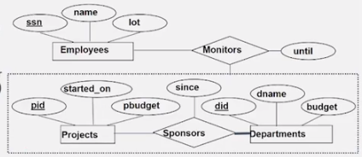

* + 1. Time periods require Ternary Relationship (third entity participates in relationship)
       1. Relationships can have attributes that do NOT rely on the presence of their entities but CANNOT have attributes that rely on the presence of their entities as the attribute would disappear if related entity disappears
       2. In order to introduce a time period into ER you need to add a ternary “duration” entity to the relationship and that duration relationship has the attributes from and to, e.g.: (problem with having from and to attributes to works in is what if employee works for two or more different periods for department – this would violate binary relationship)

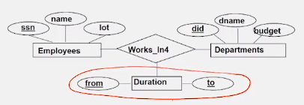

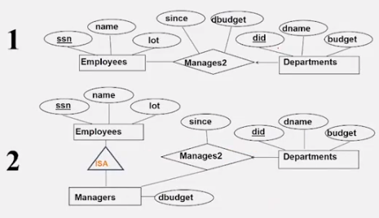

* + 1. Above Example shows different designs for applying a budget to a department when an employee is allowed to manage more than one department
       1. First (**1**) shows an individual budget for each department
       2. Second (**2**) shows a budget associated with a manager who can spend it on whatever department they manage
    2. Ternary relationships can be used to clarify relationships in the database, e.g.:

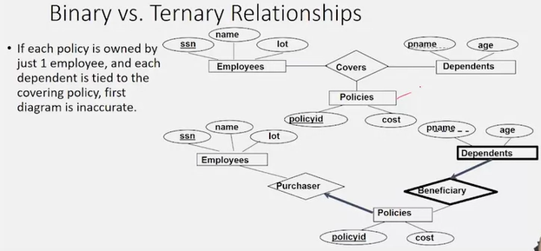

* + - 1. The top relationship only shows that an insurance policy is related to an employee and a set of dependents whereas
      2. Second scheme breaks the “covers” relationship into 2 parts: “purchaser” and “beneficiary” entities which is clearer?

1. Background Info RE Converting Entity Relationship (ER) model to Relational Database (L5)
   1. If single entity create table with attributes and primary key, then insert data
   2. If relation, create a table of the relation:
      1. Instance = a table with rows and columns
         1. #Rows = **cardinality**
         2. #Columns/fields = **degree**
      2. Schema = specifies name of relation, plus name and type of each column
         1. **(RAMA 59)** relation instance schema describes the column heads for the table, i.e., it specifies the relation’s name, the name of each field (or column or attribute), and the domain of each field with domain being referred to by its name and set of associated values, e.g., Students(sid: string, name: string, login: string, age: integer, gpa: real)
      3. The relationship model requires that each tuple in a relation must be unique, but in practice you can have duplicate rows
   3. The primary key of a relation is a tuple of the primary keys of the two entities created via two foreign keys set up to refer to the primary key of other entity
      1. One-to-many relationship set up when one primary key of one entity appears only once, but that primary key of the other entity appears many times
   4. Using SQL to create Relational Database from ER
      1. SQL allows you to create the schema or relations based on a design and to query **(RAMA 62)** Data Definition Language (DDL)

CREATE TABLE STUDENTS # delete via DROP TABLE Students

(sid: CHAR(20) # CHAR(20) = 20 character string

name: CHAR(20)

login: CHAR(10)

age: INTEGER

gpa: REAL) # REAL = float

INSERT INTO Students(sid, name, login, age, gpa)

VALUES(53688, ‘Smith’, ‘smith@ee’, 18, 3.2)

UPDATE Students S

SET S.age = s.age +1, s.gpa = s.gpa – 1

WHERE S.sid - 53688

DELETE

FROM Students S

WHERE S.name = ‘Smith’

ALTER TABLE Students # this adds column/attribute

ADD COLUMN firstYear: integer

CREATE TABLE ENROLLED

(sid: CHAR(20)

cid: CHAR(20)

grade: CHAR(2)

PRIMARY KEY (sid, cid)) # or PRIMARY KEY (sid), UNIQUE (cid, grade)

* + 1. Integrity Constraints (IC) = condition must be true for any instance in database **(RAMA 63+)**
       1. Specified when schema is defined, *i.e*. comes with the schema
       2. Business rules automatically checked by DBMS when relations are modified
       3. A legal instance of a relations is one that satisfies all specified ICs and databases should not allow illegal instances – this avoids data entry errors and assures data more faithful to real-world meaning
       4. Examples: Foreign Key, No Null, Unique, Check
    2. Primary Key Constraint = primary key value is unique for entire relation
       1. A set of fields is a key unique for a relation if:
          1. No two distinct tuples can have same values in all key fields, and
          2. This is not true for any subset of the key
       2. NOTE that a primary key can be a combination of multiple fields such as a combination of the student ID and course ID in a student database but must have non-null value
          1. Or you can split the two fields such as making the student ID the primary key but then making the course ID unique
       3. An attribute cannot be a primary key of a relationship, only an entity
       4. Superkey is one key chosen to be the primary key for the entire database
          1. Superkey can retain redundant columns, even all columns and = table
    3. Foreign Keys = set of fields in one relation that is used to “refer” to a tuple in another relation like a logical pointer – must correspond to primary key of second relation, *i.e*. it must be/is like a pointer to the primary key in the second relation – below = Students which is pointed to from Enrolled (NOTE: foreign key can be null), i.e. foreign key points to primary key
       1. The key may be unique in the second relation and not unique in first
       2. Referential Integrity requires **every value in first relation to refer to a value in second relation** which is defined by REFERENCES below

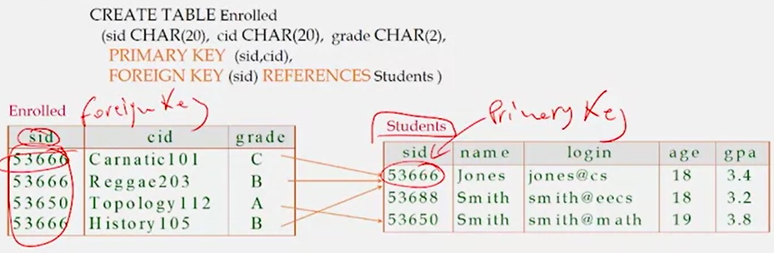

* + - 1. Enforcing Referential Integrity – if first relation tuple references a non-existent key in second relation the reference must be rejected to keep from injecting improper data into table
         1. You disallow deletion of tuple pointed to in second relation (no action), or
         2. If the tuple pointed to in the second relation is deleted, must also delete the tuples in the first relation that refer to it (cascade), or
         3. Set key in first relation that refers to deleted key to a default key (set null/set default)

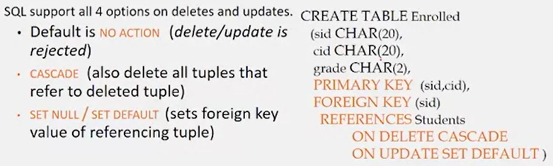

1. Converting Entity Relationship (ER) model to Relational Database (L6) **(RAMA 85+)**
   1. Entity sets to table is straightforward:

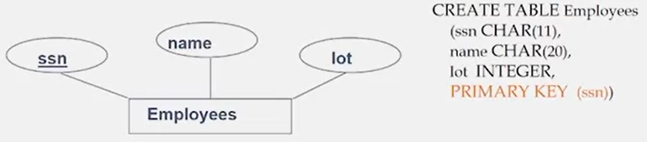

* 1. Relationship sets to tables require a tuple primary key with references for these foreign keys:

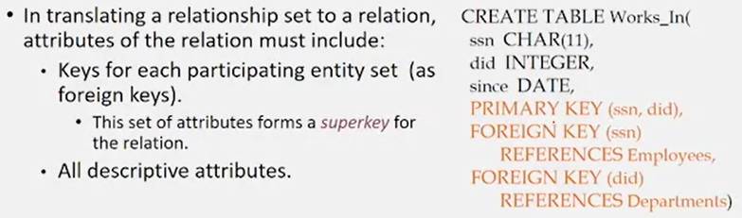

* 1. One-to-Many with key constraint – 2 different ways of attacking:

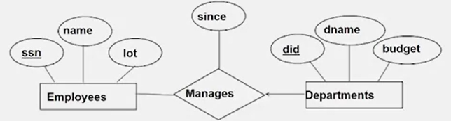 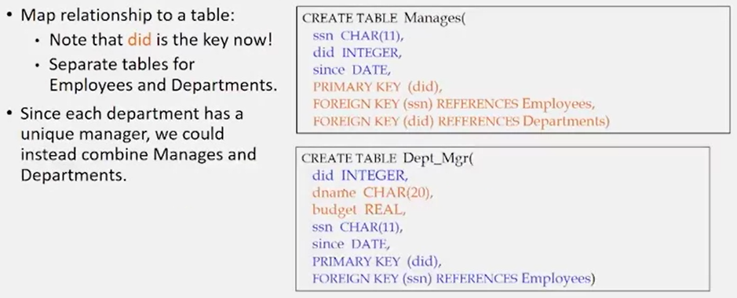

* 1. Partition Constraints when entity must participate requires NOT NULL syntax and note ON DELETE NO ACTION syntax: (key constraint = a department must have one manager, thus dark arrow)

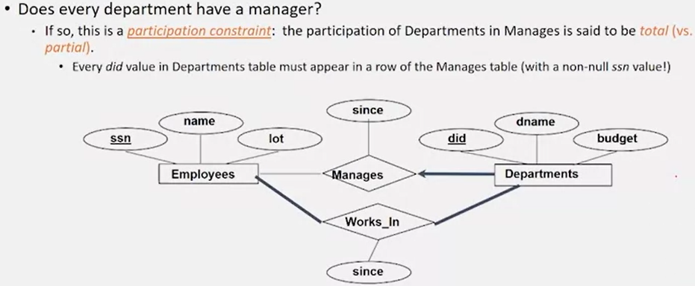

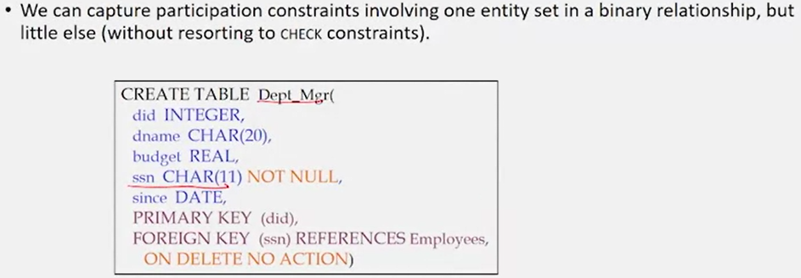

* 1. Weak Entities – can be identified uniquely only considering the primary key of the owner entity – note ON DELETE CASCADE
     1. Owner entity set and weak entity set must participate on a one-to-many relationship with one owner and many weak entities
     2. Weak entity set must have total participation in this identifying relationship set

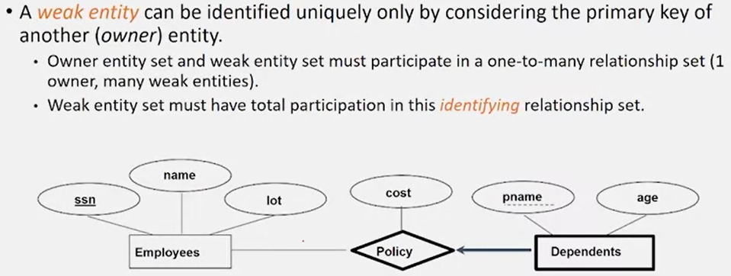

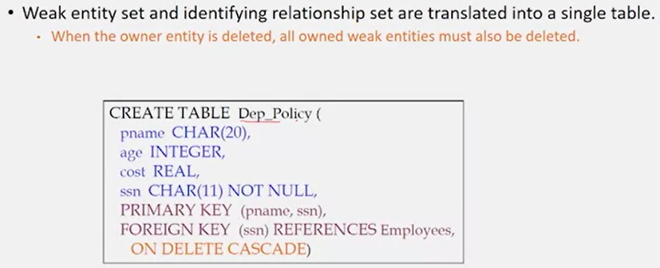

* 1. Class Hierarchies – lecture here is ridiculously awful 7:20-7:50 w/no real explanation

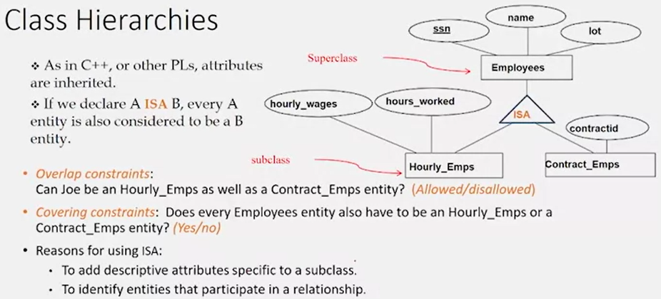

Translating ISA Hierarchies to Relations:

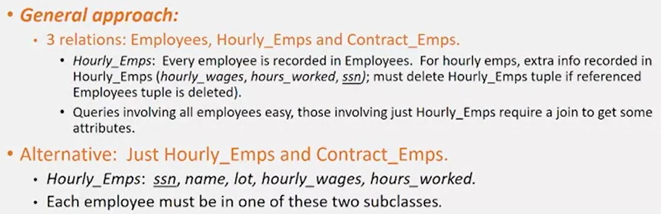

* 1. Binary v. Ternary Relationships: binary can only have single relation btwn entities

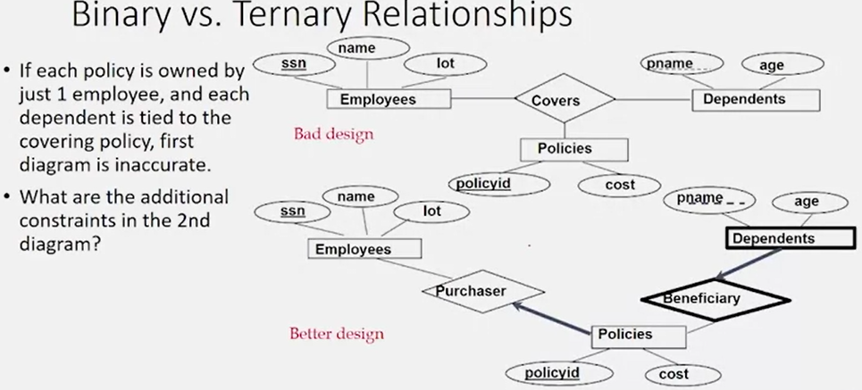

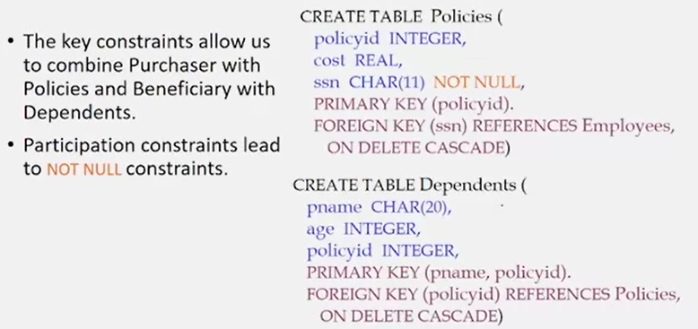

1. Programming Assignment 1 – Create Movie Recommendation Database
   1. Turn this ER Diagram into a postgres DB:



1. Relational Data Model (L7 – L14)
   1. Rows represent entities stored in table/relation
   2. Columns represent attributes of entities stored in table/relation
      1. Each column has a domain of the value of the column and the cardinality of this domain is the set of values that the domain represents (note that in II *supra* cardinality is described as the number of rows in the table)
   3. Two different types of languages (query language) in a relational database:
      1. Procedural/**Operational**/Imperative Language
         1. Instructs system to perform a sequence of operations to compute a final result of a query
         2. Example: **Relational Algebra** which has several operators:
            1. Union: finds union set between two tables/relations: r U s = {t|t ϵ r V ϵ s}
            2. Intersection: finds intersection set between two tables: r ∩ s = r – (r – s)

Finds common tuples between r and s

* + - * 1. Difference: finds difference of one set – another set: r - s = {t|t ϵ r Λ /ϵ s}
        2. Cartesian_product: puts all rows in two table/relations together

r x s = {t|t = trts where tr ϵ r Λ ts ϵ s}

You end up with number of rows in r * number of rows in s rows and each rows has all of the column available in either r or s

I do not see where this would be of use

* + - * 1. Ө-Join: joins two relations in a database similar to cartesian_product but has a selection predicate Ө so it does not combine ALL rows and columns of table/relation: r ∞Ө s ≡ ơӨ (r x s)

You say column in one has to be equal to column in another

If you do not have a predicate then you get a natural join with assumed only one overlapping column and keys take priority

* + - * 1. Selection: select particular rows on table/relational based on predicate: ơ p(r)

ơ = sigma and stands for “selection”

You can use as many Boolean operators between multiple predicates as you want.

p = predicate which is a condition applied to every row

Facilitates information filtering via selection predicate

* + - * 1. Projection: filters or projects a set of attributes in the relations out of all the relations present in a table/relation: π A(r)

Picks out and only returns specific attributes/columns from table

* + 1. Non-Procedural/**Declarative Language** = you do not have to write code for operations (L15)
       1. User uses to tell what data is to be retrieved but does not tell the system how to retrieve the data as the system figures out how (sequence of operators) to find the data
       2. Example: Relational Calculus
       3. Example: SQL Basic SQL query:

**SELECT** [DISTINCT] target-list DISTINCT is optional to block dupes

**FROM** relation-list

**WHERE** qualification

AND (comparison of attributes using AND or OR)

Can also use GROUP BY and UNIQUE and EXISTS and HAVING COUNT

* + - * 1. Relation-list = list of relation names possibly with range-variable after each
        2. Target-list = list of attributes or relations in relation-list
        3. Qualification = comparisons using =, <, >, AND, OR, NOT
        4. DISTINCT = optional keyword indicating result should contain no duplicates
      1. Conceptual Evaluation Strategy = inefficient but the DB’s optimizer will find same result
         1. Semantics of an SQL query defined in terms of following evaluation strategy:

Compute cross-product of relation-list

Discard resulting tuples if they fail qualifications

Delete attributes that are not in target-list

If DISTINCT is specified, eliminate duplicate rows

* + - 1. Set-Comparison Operators: IN, EXISTS, UNIQUE, NOT IN, NOT EXISTS, NOT UNIQUE, ANY, ALL Examples: (L16)
         1. Find sid’s of sailors who have reserved a red or green boat: two ways

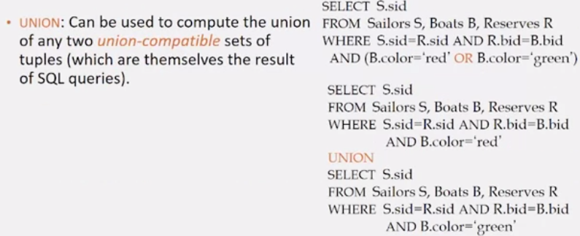

If we wanted to find sailors who reserved a red AND a green boat we would either change OR to AND on top version of UNION to INTERSECT:

NOTE how syntax gets messy

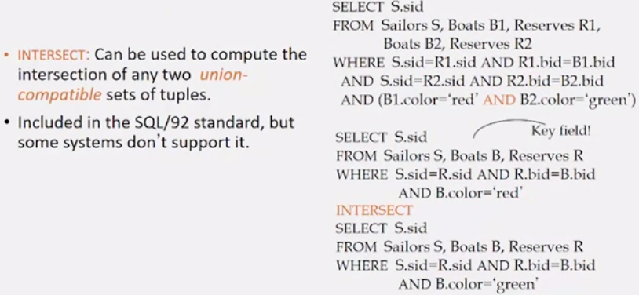

* + - 1. Nested queries = WHERE has a separate query that it looks to
         1. Very powerful SQL feature where WHERE clause can contain separate query using code IN or NOT IN

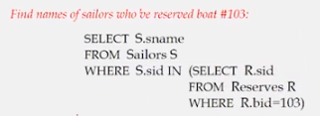NOTE: this is same as above query

* + - * 1. FROM and HAVING clauses can also contain separate queries
        2. Nested queries are immediately turned into intersects +, but are such clean syntax they are used – inner query should return non-null results
      1. Correlated Query = nested query but table in inner query comes from outer query
         1. If you used UNIQUE in inner query than only works if there is an instance
      2. More Set-Comparison Operators: UNIQUE, EXISTS, NOT UNIQUE, NOT EXISTS, ANY, ALL
         1. Can use operators: >, <, =, ≥, ≤, ≠
      3. Find sids of sailors who’ve reserved both red and green boats (INTERSECT using IN)

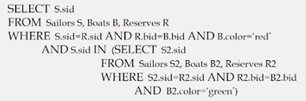

1. Spatial Data (L17 – was not in Coursera course)
   1. Digital traces with geospatial location – often with polygon that represents space where data collected such as a state/county/city
      1. Google Maps find, Uber, Zillow, data tied to physical space and reality, 3-dimensional
      2. Very tied to physical space
      3. Multi-dimensional
         1. Traditional data like DOB = 1-dimensional
         2. Location via latitude and longitude = 2-dimensional
         3. time can be a 3rd dimension
      4. Complex geometric shapes – not just one point location - what polygon holds the data can include a 3rd dimension
      5. New query API – questions that are asked are not the same
   2. Spatial data queries
      1. Range query, e.g. all taxi trips that have been picked up in or at a certain area which is a input range which can be a polygon or a simplified rectangular range
      2. KNN (K nearest neighbors) query – instead of returning objects in a range it returns k number of neighbor object to a single input location
      3. Spatial join query – joins searches in two spatial databases, e.g. all taxi trips from a hospital
   3. Efforts to expand SQL to support spatial data – PostGIS is an add-on to PostgresSQL for spatial data
      1. Has new data types, e.g. geometry which represents a polygon or a point (name.geom)
      2. NOSQL databases have also added spatial, e.g. mongoDB has dbnam.findOne and geoWithin which use long/lat coordinates with 8 digits right of the decimal point

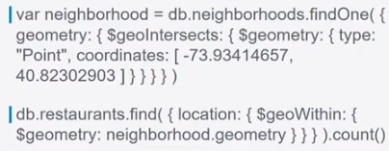

1. Data Storage and Indexing (L18 ? **Unit 3 START RAMA 274, 305**)
   1. The Memory Hierarchy – from slow to fast
      1. Secondary storage device = hard disk or tapes
      2. Main Memory = RAM
      3. L3 -> L2 -> L1 caches
      4. CPU registers

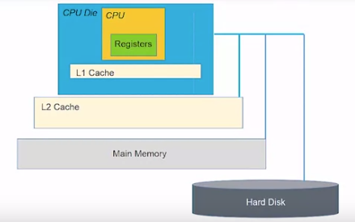

* + 1. File Organization = how you arrange records on external storage
  1. Data Management System Architecture
     1. Buffer manager = required software component that stages pages from external storage to main memory buffer pool
     2. File in index managers make calls to the buffer manager

1. **Searching v. Selecting**
   1. Selecting = answering selection queries written in SQL which may involved several operations such as parsing the query, creating a query plan, using indices if required for searching and once the matching data is found we can perform further operations such as joins and aggregates to eventually return the selected data to the user
   2. Searching = a specific step within the selection process during which data to be retrieved is found withing the memory or hard disk. Indices can help in searching data. Typically WHERE clauses involving selection predicates end up leading to the search as they specify the exact subset of data to be retrieved
2. Alternative/Different File Organizations (L19 ? **Unit 3 CONT’D**) Number of Pages Read = I/O Cost
   1. **Heap Files** (see reading material about buffer manager and replacement policies to be posted) (**RAMA 288**)
      1. Random order of data – you just keep inserting it w/o sorting = it is fast
      2. Suitable when typical access is a file scan retrieving all records
      3. Advantages:
         1. Efficient
            1. easy add bulk data into file as no particular order, you merely append
            2. relatively small relations/data as indexing overhead avoided
            3. when queries that need to fetch large proportion of stored records
      4. Disadvantages:
         1. Not efficient
            1. For selective queries (finding a needle in a haystack)
            2. If you need the data in the heap file sorted, sorting may be time consuming

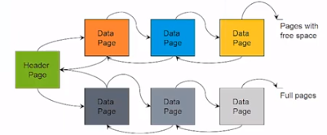

* 1. Cost Model – each approach to storing database data has its own pros and cons
     1. Different ways of adding new data and accessing data depending on how it is stored
     2. Cost measure = number of pages accessed - reasoning:
        1. Page access or I/O cost is usually the dominant cost of database operations
           1. This is where Sarwat mentions reading 3 pages is faster than reading one page
           2. If you have good estimates of I/O cost you can optimize queries running on DB
        2. An accurate model is too complex for analyzing algorithms
  2. **Sorted Files** – sorted based on some attribute (**RAMA 285**)
     1. Best if records must be retrieved in some order, or only a “range” of records is needed
  3. **Indexes** = index on top of data structure allowing you to go right to data and not iterate (**RAMA 288-89**)
     1. Data structures to organize records via trees or hashing that are created upon specific attributes/columns of a table. All the nodes within a tree index for instance represent the possible values that an attribute can take. Finally, at the leaf node, we store pointers to the actual records within the disk. It is essential that these records are part of the same table, apart from that there is no other significance to the notion of a table in an index. This is because, an index stores either exact rows in its leaves or record IDs which point to the rows from a specific table (upon which the index has been created)
     2. Speeds up selections on the search key fields (not for very small databases due to overhead and it might divide data up into multiple pages when it could fit on one single page – high selectivity means a high % is accessed so indexing not helpful, whereas low selectivity an index is helpful)
     3. Any subset of the fields of a relation can be the search key for an index on the relation
     4. An index contains a collection of data entries, and supports efficient retrieval of data entries k* with a given values k
     5. **B+ Tree Index** is very popular and is binary search tree with sorted pages as leaves (**RAMA 280, 344**)
        1. The non-leaf “pages” or “index entries” or nodes of the tree are the indices and are only used to direct searches (leaf nodes are stored in doubly linked lists)
           1. K1, K2 . . . Km = keys
           2. P0, P1, P2 . . . Pm are pointers at each end

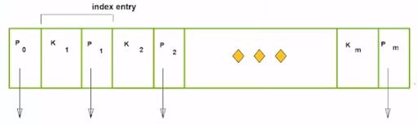

* + - 1. You use a key to create an index with multiple values on the key in the non-leaf pages
         1. There are two pointers: one on the left side and it contains all the values that are less than itself and one on the right side that contains all values that are greater than the key (the tree is built recursively on what looks like sorted)
         2. P1 <= 17/Pm > 17
         3. P2 < 5 /5 <= P3 < 14/22 < Pm-2 < 27/27 <= Pm-1 < 33/Pm >= 33

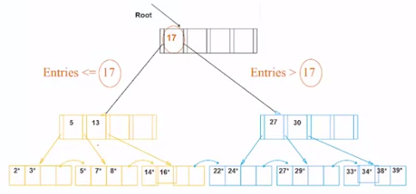

^^^ above = B+ Tree ^^^ Here K1 = 17 and Km = > 38 and between those you can number however you wish, for example the K that is <= 5 could be K2 but does not have to be

Data entries indicate the leaf node entries of a **tree index**. In the case of a **hash index**, data entries refer to the **hash buckets** containing the corresponding set of records. **Data entries can be stored in three ways** - 1) Either store the record itself physically within a data entry, 2) Store the search key value and a record ID that points to the matching record, 3) Store the search key value and the list of recordIDs that point to the bunch of matching records. While option 1 is employed within a clustered index, options 2 and 3 are used in unclustered indices.

<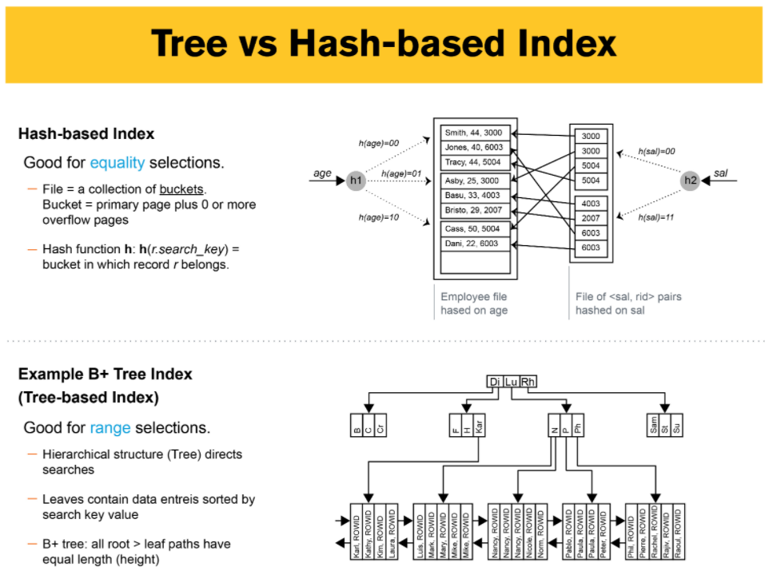<<< (**RAMA 279-80)**

* + 1. **Hash-Based Indexes** = good for equality selections = select specific entry/object based on attribute e.g. SELECT student WHERE age = 10 or ID = 2 or your bank account is found (L20? **Unit 4 START**) (**RAMA 279, 371)**
       1. Hash formula is mathematical formula and hash function is based on attribute on which you do the hashing -> goes to Data Buckets so you put in search key, it is hashed through formula, and it takes you to a bucket containing the entry you seek
       2. Both creating hash index and searching for entry once hash index built use the hash formula and ultimately h(r) = bucket in which (data entry for) record r belongs. h looks at the search key fields of r
  1. Alternative for Data Entry *k in index
     1. Index (B+ Tee Index leaves [non-leaf nodes = index entries and leaf nodes = entries in the index that have pointers to where data is stored]) entries are pointers to data location – can store one of three:
        1. Data record with key; or
        2. Record ID of data record with search key value k; or
        3. List of record IDs of data records with search key k (can have multiple entries with same key)
  2. Different classes of indices – Index Classification (L21?)

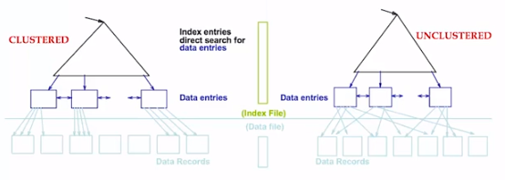

* + 1. Clustered – index entries sorted by key attributes the same as data entries which are pointers to actual data (**RAMA 287, 292**)
       1. Data is stored in the leaves sorted in same manner as data storage – index matches
       2. Therefore, for a single table or relation, you can have only one clustered index
       3. Data is not always sorted
    2. Unclustered – sorting order of data entries is not related to sorting order of actual data (**RAMA 288**)
       1. For a single table or relation, you can have as many unclustered indices as you want
    3. What kind of classification should we use for a given table? **Depends on workload** - Factors:
       1. Which relations does it access?
          1. If all the same this would be a good relation upon which to create an index
       2. Which attributes are retrieved?
          1. This is what is mention in the SQL “WHERE” clause
       3. Which attributes are involved in selection/join conditions?
       4. How selective are the conditions likely to be?
          1. If very selective then index makes more sense
          2. Whereas if the queries will usually retrieve 90% of the data then an index does not make sense
       5. Type of updates (INSERT/DELETE/UPDATE) which is storage and maintenance overhead
          1. Maintenance is a big deal if you have a lot of updates to the table
    4. Choices of Indexes – factors RE what indexes you should create:
       1. Which relations should have indexes?
       2. What field(s) should be the search key?
       3. Should you build several indexes?
       4. For each index, what kind of index should it be?
  1. Creating a new index – what to look at when a “better plan” = get to the data faster:
     1. Consider most important queries in application
     2. Consider best plan using the current indexes
     3. Determine if a better (faster) plan is possible with an additional index and if so create it
     4. Index Selection Guidelines:
        1. Attributes in WHERE clause – these are candidates for index keys
        2. Primary key or unique attribute in table are candidates for indexing
        3. Multi-attribute search keys – keys should be considered when a WHERE clause contains several conditions
        4. Indexes benefit multiple queries – since only one index can be clustered per relation, choose it based on important queries that would benefit the most from clustering
        5. EXAMPLES:

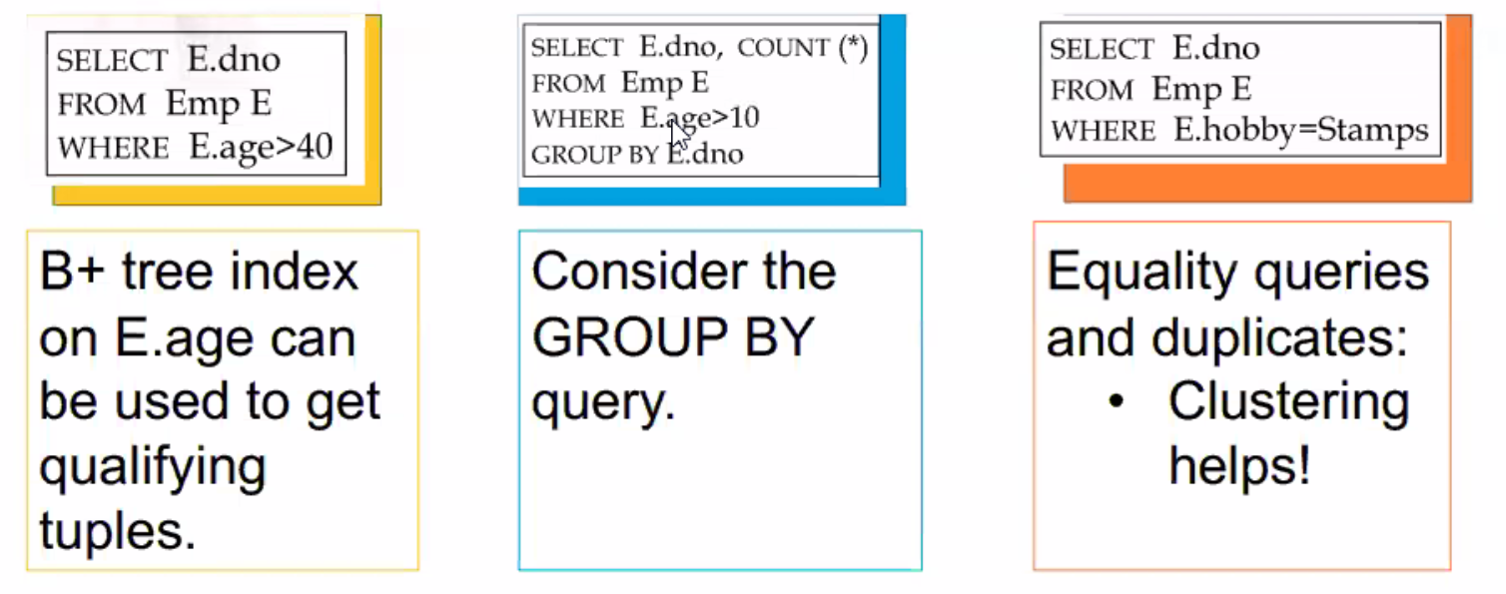

* + - * 1. When searching for ranges a B+ tree index makes sense
        2. When searching for groups a GROUP BY query an index makes sense
        3. Equality queries benefit from clustering – perhaps hash-based index is good
        4. Composite search keys call for a composite index, e.g. age and salary

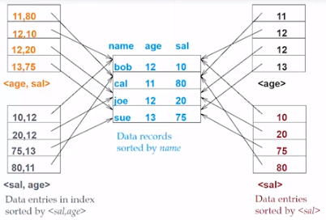

Major and Minor columns – what key is bet depends on DB organization

You run through one index, then the other – can go either way

Orthogonal to Clustering – to retrieve employee records with age=30 and sal=4000 use an index <age,sal> as **salary is more selective**

Clustered – if condition age=30 AND 3000<sal<5000 clustered <age,sal> index much better than <sal,age> index because **age is more selective**

Clustered Tree – if conditions 20<age<30 AND sal 3000<sal<5000 either index <age,sal> or <sal,age> works roughly the same

A number of queries can be answered without retrieving any tuples from one or more of the relations involved if a suitable index is available, i.e. you might not need to go to the main data in the DB.

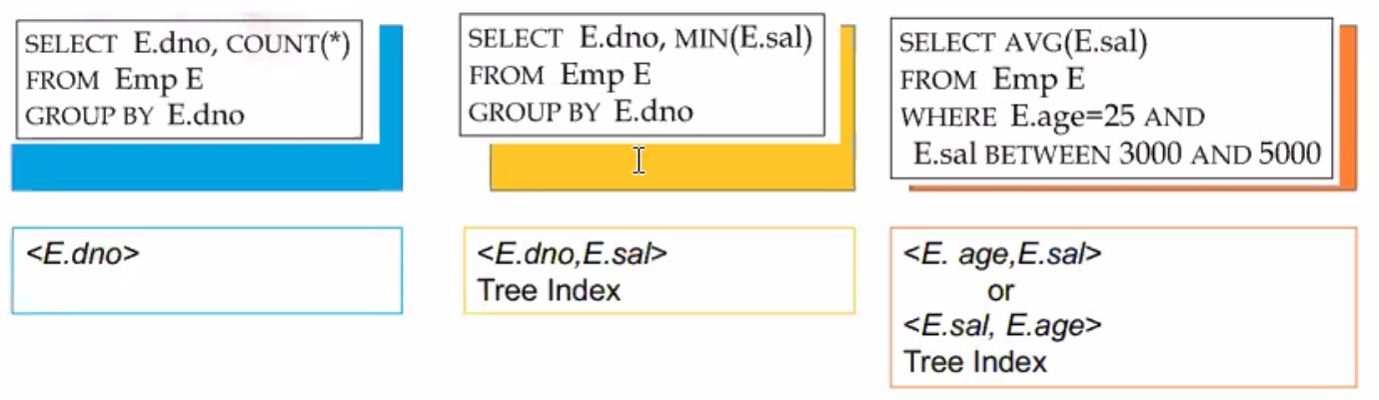

Above if only searching Department Number (X.dno) and there is an index on dno then all keys are in the index already and you do not need to go to the main db as index has what looking for

Above same if you have composite search key

Above is example of where two index contain the needed keys

* 1. An **index-only plan** means that a **(non-clustered) index contains all the columns needed to answer the query without having to access the tuples in the base relation**. This gives a very efficient execution for two reasons:
     1. it avoids the one disk I/O per tuple that is usually needed when  
        using a non-clustering index (to retrieve the columns not in the index)
     2. the index is typically much smaller than the base relation (because  
        it contains many fewer columns per tuple), so if most of the tuples in  
        the relation are being returned, scanning the index is much faster than  
        scanning the base relation

1. Transaction Processing (L20? **UNIT 5 START**) (**RAMA 520**)
   1. Transaction = user programs to either read or write data to database – can be multiple at a time
      1. Not just a query, but rather a transaction is a series of reads and writes in the database
   2. Concurrency in a DBMS: one option for simultaneous transactions presented to a DSB is a queue and run them one-by-one (a Series Schedule) but this leads to poor performance so interleaved actions achieved by concurrency were developed
      1. Users submit transactions
      2. Concurrency is achieved by the DBMS which interleaves various transactions
      3. Each transaction must leave the database in a consistent state, i.e. all integrity constraints satisfied
         1. Database can temporarily be in an inconsistent state during execution of a transaction between consistent states at beginning and end of transaction
         2. This is achieved by Principles of Transactions: **ACID Properties**:
            1. **Atomicity** = all or nothing = every transaction/program needs to be atomic which means all of the components of a transaction run in their entirety, or none of them run at all
            2. **Consistency** = no violation of integrity constraints – Internal Consistency means:

A transaction which executes alone against a consistent database leaves it in a consistent state, i.e. a transaction transforms a database from one consistent state to another consistent state

Transactions do not violate database integrity constraints

In other words, “programs” need to be bug-free and work, i.e. correct (violating integrity constraints = bug for DBMS)

* + - * 1. **Isolation** = concurrent changes => serializable, i.e transactions execute independently from one another (you feel like you are only transaction)

Serializability = if several transactions are executed concurrently, the results must be the same as if they were executed serially in some order, i.e. as if there are no other transactions running concurrently and the results of another transaction cannot be revealed to a transactions until the transaction is committed

Incomplete results = an incomplete transaction cannot reveal its results to other transactions before its commitment

* + - * 1. **Durability** = committed updates persist = once a transaction commits, the system must guarantee that the results of its operations will never be lost, in spite of subsequent failures – allowing database recovery
  1. **Concurrency Control** (L21? **Unit 5 CONT’D**)
     1. Schedule= name for concurrency actions

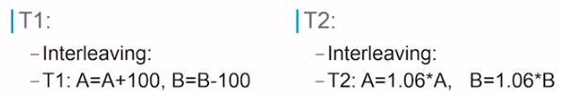

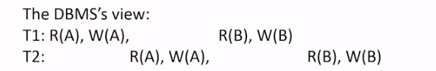

* + 1. Scheduling transactions
       1. Serial Schedule = does not interleave the actions of different transactions
       2. Equivalent Schedule = for any database state, the effect of executing the first schedule is identical to the effect of executing the second schedule
       3. Serializable Schedule = equivalent to some serial execution of the transactions
          1. A schedule is serializable when it is equivalent to some serial schedule
       4. Conflict Serializable Schedules
          1. Two schedules are Conflict Equivalent if:

They involve the same actions of the same transactions

Every pair of conflicting actions is ordered the same way

* + - * 1. Schedule S is Conflict Serializable if S is conflict equivalent to some serial schedule
      1. Dependency Graph is used to determine if transactions are conflict serializable
         1. One node per transaction
         2. Edge from Ti to Tj if Tj reads/writes an object last written by Ti. Using schedule labeled “The DBMS’s View” above but adjusted as below we have: (edge points from who last wrote)

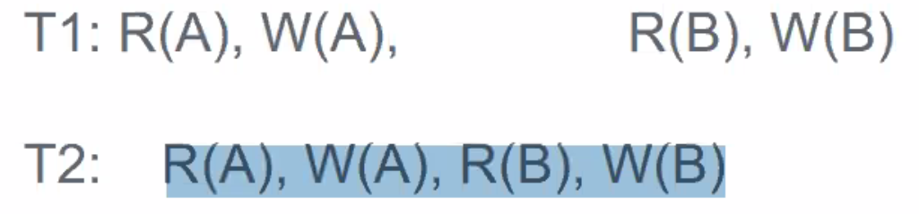

A = an edge from T1 to T2 because T2 reads/writes object A last written by T1, and

B = an edge from T2 to T1 because T1 reads/writes object B last written by T2

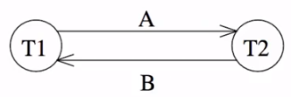

* + - * 1. You know the schedule is conflict serializable if there is no cycle in the graph. Here there is a cycle so this graph is NOT conflict serializable
  1. Lock-Based Concurrency Control = assures concurrency on a global level (wider view than graph) (L22? **UNIT 6 START**) (**RAMA 530**) - note that in the real-world transactions come to DB “on the go”
     1. **Strict Two-Phase Locking** (Strict 2PL) Protocol:
        1. Each transaction must obtain a **Shared Lock** on object before reading, and an **Exclusive Lock** on object before writing
           1. Shared Locks can be upgraded to Exclusive Locks during the process only when there are no other transactions holding a shared or exclusive lock on the object. If a shared lock as been acquired by multiple transactions and one needs an upgrade it must wait until all other transactions release the shared lock

If multiple transactions as for a lock at the same time = deadlock because each transaction asking for an upgrade waits for the other

* + - * 1. Locking and unlocking have to be atomic operations
      1. All locks are held by a transaction are released when transaction completes all at once
         1. There is a “less strict” version where locks are released less than all at once until they are all released at the end of the concurrent transactions
      2. Allows sizable serialized schedules and simplifies transaction aborts
      3. All this locking is controlled by a **Lock Manager** which is a separate system in DB
         1. If trans A has a shared lock then trans B wants a shared lock = allowed
         2. If trans A has a shared lock then trans B wants an exclusive lock = not allowed
         3. If trans A has an exclusive lock then trans B wants a shared lock = not allowed
         4. If trans A has an exclusive lock then trans B wants exclusive lock = not allowed
    1. Deadlocks = cycle of transaction waiting for locks to be released by each other
       1. There are **deadlock prevention algorithms** but they are overhead and slow operation
       2. Or you can let run and have **Deadlock Detection** is via a Waits-For Graph where:
          1. Nodes are transactions
          2. There is an edge from Ti to Tj if Ti is waiting for Tj to release a lock
       3. Periodically check for cycles in the Waits-For Graph
          1. If a cycle is found it is a true deadlock and the cycle must be broken, perhaps by aborting one of the transactions and running the aborted transaction later, here is an example with no cycles which means no deadlocks

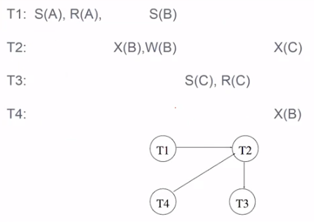Direction of edges reverse of Dependency Graph above – NOTE this graph does have directional edges just hard to see – **the latest transaction to acquire the lock is pointed to not the earliest**

* + - * 1. But if we added a new operation that required T3 to have an exclusive lock on A to the far right, T3 cannot acquire an exclusive lock on A until T1 releases its shared lock on A so we write an edges from T3 to T1 which creates a cycle

Solution could be to abort T3 and run it later

1. Database Recovery – what if there is a failure during a transaction, *e.g*. a power failure (L23? **UNIT 6 CONT’D**) Fault can => to Error can => to Failure
   1. Types if Failures:
      1. Transaction Failures
         1. Transaction aborts unilaterally or due to deadlock
         2. Average 3% of transactions abort abnormally
      2. System Failures
         1. Failure of a processor, main memory, or power supply etc
         2. Main memory contents are lost, but secondary storage contents are safe
         3. Partial v. total failure
      3. Media Failures (storage)
         1. Failure of secondary storage devices such that the stored data is lost
         2. Head crash/controller failure ??
      4. Communication Failures
         1. Lost or undeliverable messages
         2. Network partitioning
   2. Local Recovery Management – Architecture = **Recovery Manager**
      1. Volatile Storage – consists of main memory (RAM)
      2. Stable or Persistent Storage
         1. Resilient to failures and loses its contents only in presence of media failures
         2. Implemented via a combination of hardware and software (stable-write, stable-read, clean-up) components

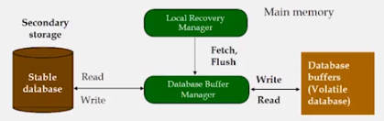

* + 1. Buffer Manager decides what pages are loading into memory from secondary storage, but if there is a failure such as a power outage and the DB data in main memory is lost, a Local Recovery Manager is what assists in recovering the state of the database

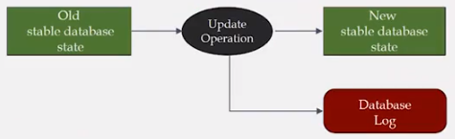

* + 1. In-Place Update Recovery Information uses a Database Log which is an append-only file that stores update operations onto persistent storage as a Write Ahead Log (WAL)
       1. Every action of a transaction must not only perform the action, but must also write a log record to an append-only file stored on secondary storage/disk – method:
          1. Trans writes an object: the old value and the new value

Log record must go to disk before the changed page!

* + - * 1. Trans commits/aborts: a log record indicating this action
        2. Log records are chained together by Xact id so it’s easy to undo a specific Xact
        3. All log related activities are handled transparently by the DBMS
      1. Log Record includes information used by recovery process to restore consistency to system and may include:
         1. Transaction identifier
         2. Type of operation (action)
         3. Items accessed by the transaction to perform the action
         4. Old value (state) of item before image
         5. New value (state) of item after image
      2. System needs to figure out what to do if system crash close to, or before commit

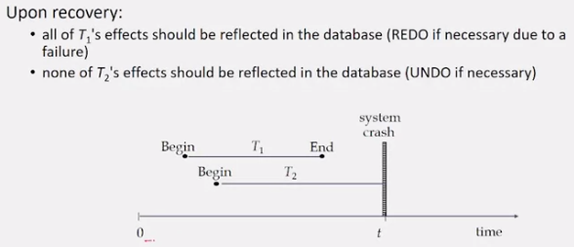

* + - * 1. Note here that T1’s commit may still be in main memory at time of failure
      1. Write-Ahead Log (WAL) Protocol
         1. Notice

If a system crashes before a transaction is committed, then all the operations must be undone and you only need the before images (undo portion of the log)

Once a transaction is committed, some of its actions might have to be redone so you would need after images (redo portion of log)

* + - * 1. WAL Protocol

Before a stable database is updated the undo portion of the log should be written to the stable log

When transaction commits the redo portion of the log must be written to the stable log prior to updating the stable database

* + - 1. Recovering from a crash timing = 3 phases or Aries Recovery Algorithm:
         1. **Analysis** – scan the los forward from most recent checkpoint to identify all Xacts that were active and all dirty pages in the buffer pool at the time of the crash
         2. **REDO Protocol** = redoing action done prior to failure means performing it again

The REDO operation uses the log information and performs the action that might have done before or not done due to failures

The REDO operation generates the new image by grabbing the image from the log because not sure if item made it to persistent storage

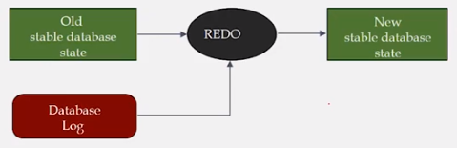

* + - * 1. **UNDO Protocol** = restoring the object that did not commit before crash to its before image using log info to bring the object back the before image value

These operations will have to be redone later

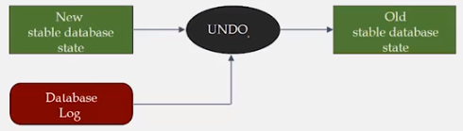

* + - * 1. **REDO and UNDO have nothing to do with deadlocks only power failures**
      1. Concurrency control and recovery are among most important functions provided by DBMS
         1. Users need not worry about concurrency as done automatically

System automatically inserts lock/unlock requests and schedules actions of different Xacts in such a way as to ensure that the resulting execution is equivalent to executing the Xacts one after then other in some order

* + - * 1. Write-ahead logging (WAL) is used to undo the actions of aborted transactions and to restore the system to a consistent state after a crash

Consistent state: only the effects of committed Xacts seen

1. Distributed and Parallel Database Systems (**UNIT 7 START**)
   1. Why Distribution (multiple machines performing DB functions)? Sharing Information and Services
      1. Availability – must be achieved
      2. Scalability – ability to service more users and if not the system will break
      3. Reliability/Fault Tolerance – if one machine is down another can perform the function
      4. Transparency – isolates the distribution of machines from the user experience
   2. Distributed DBMS Environment = multiple sites linked by a communication network – DDBS =:
      1. A collection of multiple, logically interrelated databases distributed over a computer network
      2. The SW that manages the DDB and provides an access mechanism that makes this distribution transparent to the users
      3. Distributed Database System (DDBS) = DDB + D-DBMS (system that manages distribution)
   3. Distributed DBMS Promises
      1. Transparent management of distributed, fragmented, and replicated data
         1. Separation of higher level semantics of a system from the lower level implementation issues
         2. Fundamental issue is to provide data independence in the distributed environment as query submitted to either centralized or distributed system and user does not know
      2. Improved reliability/availability through distributed transactions
      3. Improved performance – having multiple machines allows parallelism for searches
      4. Easier and more economical system expansion
   4. Data Fragmentation and Replication Models
      1. Horizontal fragmentation – divide relation into tuples called rows = simply put some rows in one fragment and the rest of the rows in another fragment (Frag 1 and Frag 2 using same name)
      2. Vertical fragmentation – divide relation into attributes called columns =simply put some columns in one fragment and the rest of the column in another fragment (Frag 1 and Frag 2 using same name) BUT here you have the primary key column in both fragments
         1. You group columns together based on how much they are accessed together which is shown by a Attribute Usage Matrix showing all queries for all attributes and leads to the calculation of the Affinity Measure shown by aff(Ai, Aj) which is the similarity of attributes when accessed together (multiple ways to calculate)

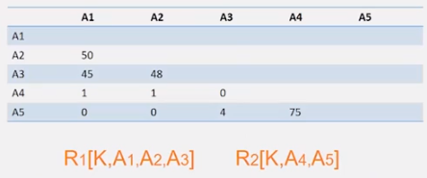

* + 1. When is a fragmentation good or bad? Relational algebra is often used
       1. F = {F1, F2} F1 = Ơ sal<10 E F2 = Ơ sal>20 E this fails due to sal gap btwn 10 and 20
       2. F = {F3, F4} F1 = Ơ sal<10 E F2 = Ơ sal>5 E this fails due to sal dupes btwn 5 and 10
       3. Better replication (lecture is absolute shit here) “sometimes you want to replicate – so you should not mix allocation with replication. First you do the fragmentation and then maybe you decide later maybe you want to replicate some of the fragment.”
          1. F = {F5, F6, F7} F5 = Ơ sal≤10 E F6 = Ơ 5<sal<10 E F7 = Ơ sal≥10 E
          2. Then replicate F6 if convenient (part of allocation problem)
    2. Desired properties for fragmentation: if you have these you have “good” fragmentation
       1. Completeness – decomposition of relation R into fragments R1, R2, . . . , Rn is complete if and only if each data item in R can also be found in some Rj
       2. Reconstruction – if relation R is decomposed into fragment R1, R2, . . . , Rn then there should exist some relational operator ◊ such that R = ◊1≤i≤nRi
       3. Disjointness – if a relation R is decomposed into fragments R1, R2, . . . , Rn and data item di is in Rj then di should not be in any other fragment Rk (k ≠ j) = no duplication
    3. Primary Horizontal Fragmentation (PHF) – a table fragmentation algorithm in which we fragment a single table and this fragmentation is row-wise and using a set of simple conditions
       1. Each fragment is a selection operator on the relation applied to original table:
          1. R: Rj = ƠFj(R), 1 ≤ j ≤ w
          2. You start with the original simple predicates that are represented in the original table R and you build a combination of these called minterm predicates which are conjunctions between different predicates or a negation of a predicate
          3. Automation algorithm starts from the minterm predicates and filters out the minterm predicates or parts of it that does not make logical sense, i.e. algorithm iterates over minterm predicates and prunes out things that do not make sense until the minterm predicate that exist are basically the fragmentation that you have
       2. A horizontal fragment Ri of relation R consists of all the tuples of R which satisfy a minterm predicate mi
       3. Given a set of minterm predicates M, there are as many horizontal fragments of relation R as there are minterm predicates
    4. Derived Horizontal Fragmentation – in order to decompose into fragments you need another attribute from another relation, e.g. if you want to fragment an employees table based on salary and salary is in another table you need to grab salary from the salary table in order to fragment the employees table by salary
       1. Owner relation = the relation including the attribute from another relations
       2. Member relation = the relation without the attribute from the other relation
       3. After you do the fragmentation on the owner relation using the selection operator you do a semi-join with the original table to get the fragments for the member relations
    5. Hybrid Fragmentation = vertical and horizontal fragmentation together on same relation

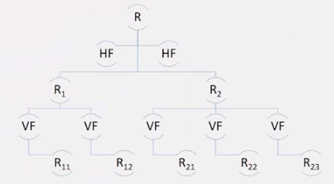

1. Replication = post fragmentation you may need to replicate different fragments among sites – why?
   1. Increased availability
      1. if increase fragments and one site goes down, the fragment will be available
      2. even if there is no site failure having replicated fragments can increase throughput if the replicated fragment is highly used by way of rerouting query to alternative site
   2. Faster query evaluation
      1. replicated fragments can increase speed if the replicated fragment is highly used by way of rerouting query to alternative site – he gives Facebook as an example
      2. You can also put the data close to where its accessed by replicating fragments close to where it is accessed, e.g. on same server where it is accessed
   3. Updates are challenging
      1. if you have many replicated fragments as each need to be updated
      2. concurrency control can also be complicated by replication
   4. Allocation Alternatives
      1. Non-replicated = partitioned = each fragment resides at only one site = sharded deployment
      2. Replicated
         1. Fully replicated = each fragment replicated at each stie
         2. Partially replicated = each fragment replicated at some of the sites
      3. Rule of Thumb for replication = if (read-only queries/update queries) > 1 then replication is advantages otherwise replication may cause problems that need to be overcome
   5. Fragment Allocation = start with a Problem Statement then find the optimality which = minimal costs and best performance and best response to and throughput
   6. Fragmentation issues: practically no algorithm can perfect each of these
      1. Where do queries originate? A lot of people log in from other locations?
      2. What is communication cost? What is cost of transporting fragments to other locations?
      3. What is storage capacity cost at sites and size of fragments?
      4. What is processing power at sites?
      5. What is query processing strategy? Optimizer takes this into account.
      6. Do you replicate fragments?
      7. What is the cost of updating copies?
      8. Writes and concurrency control?
   7. Optimization Problems:
      1. What is the best placement of fragments and/or best number of copies to:
         1. Minimize response time?
         2. Maximize throughput?
         3. Minimize “some cost?”
      2. Subject to constraints:
         1. What is available storage?
         2. What is available bandwidth and power etc?
         3. How cab it be kept to 90% of response time below X?
2. Query Processing in Distributed Databases (**UNIT 7 CONT’D**)
   1. High level user query = SQL
   2. Query Processor = take high level query language and generates low-level data manipulation commands for the distributed database
   3. Query Processing Components
      1. Query language that is used – SQL
      2. Query execution methodology = steps that system goes through in executing high-level (declarative) user queries
      3. Query optimization = how do we determine the “best” execution plan
   4. Selecting Alternatives – even if return same exact answer, performance may not be equal, e.g. here Strategy II better than Strategy I because selecting managers first the join with employees faster

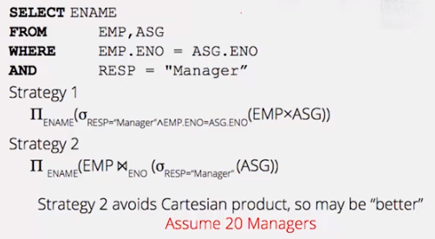

* + 1. Assume fragments in 4 different sites and result needs to be in 5th site.
       1. Easiest way I to bring all fragments into 5th and run computation (on right below)
       2. Alternative is to apply some computation in various sites then transfer results with perhaps multiple levels of calculation and transfer (on left below)
       3. Choosing the best alternative

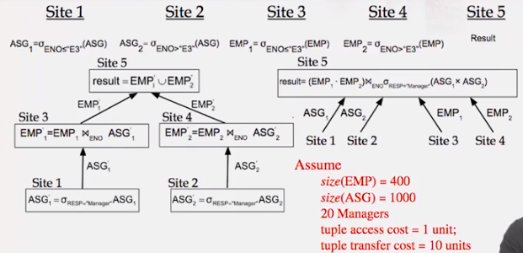

* + - * 1. First level of left if indexed = 10 + 10 = 20
        2. Second level of left = [2(10 + 10) = 20] + 200 = 240
        3. Third level of left = 2(200) = 460
        4. RIGHT plan starts out at 10(1000 + 400) = 14,000 SEE SLIDE FOR BETTER
  1. More distributed query processing:
     1. Control Cite:
        1. Calculus Query on Distributed Relations
        2. Query Decomposition <= Global Schemas
        3. Algebraic Query on Distributed Relations
        4. Data Localization <= Fragment Schema
        5. Fragment Query
        6. Global Optimization <= Stats on Fragments
     2. Local Sites:
        1. Optimized Fragment Query w/Operations Communication
        2. Local Optimization <= Local Schemas
        3. Optimized Local Queries
     3. Query Processing:
        1. Decomposition
           1. Normalization = convert from general language to a “standard” form, e.g. Relational Algebraic
           2. Eliminate redundancy
           3. Algebraic rewriting
        2. Localization = replace relations by corresponding fragments
           1. Start with query
           2. Replace relations by fragments
           3. Push union of fragments up and selection down
           4. Simplify – eliminating unnecessary operations
        3. Optimization
  2. Total Cost of Query/Execution Plan
     1. CPU cost + I/O cost + communication cost
        1. CPU cost = unit instruction cost * number of instructions
        2. I/O cost = unit disk I/O cost * number of disk I/Os
        3. Communication cost = message initiation + transmission
     2. Response time = CPU time + I/O time + communication time
        1. CPU time = unit instructions time * number of sequential instructions
        2. I/O time = I/O time * number of sequential I/Os
        3. Communication time = unit message initiation time * number of sequential messages
        4. + unit transmission time * number of sequential bytes
     3. Optimization Statistics (can be simple like how many rows and columns in each table)
        1. Primary cost factor = size of intermediate relations – need to estimate their sizes
        2. Make then precise => more costly to maintain
        3. Simplifying assumption = uniform distribution of attribute values in a relation
     4. I/O May Not be the Best Metric (as opposed to it being good for centralized DB)
        1. Multiple sites work in parallel so even if more I/Os in total could be faster
     5. Query Separation
        1. Separate query into 2 or more steps
        2. Optimize each step independently

1. Parallel DBMS (**UNIT 8 START**)
   1. A distributed DB system does is not need to be a parallel DB system but it can be
   2. Pipeline Parallelism = many machines doing one step in a multi-step process
      1. Like a manufacturing line at an automotive plant
   3. Partition Parallelism = many machines doing the same thing to different pieces of data
      1. Partition the data, then have different machines perform same function on different partitions
   4. Speed Up = more resources means proportionally less time for given amount of data
      1. As data increases the speed of operations increases linearly is the goal
   5. Scale Up = if resources increased in proportion to increase in data size, time is constant
   6. Architectural issues: what is shared
      1. Shared Memory (SMP) = multiple CPUs that can runs things in parallel but share same memory space
         1. The multiple CPUs can be running in the same machine
         2. CPUs communicate with each other through a shared memory space
         3. Easy to program due to shared memory and no need for distributed computing
         4. Expensive to build
         5. Difficult to scaleup because if you have more data you need to increase memory size
      2. Shared Disk = multiple CPUs and each has its own memory space
         1. The closest way machines can communicate is through the secondary storage disk space
      3. Shared Nothing = multiple CPUs have their own memory space and their own secondary storage
         1. The only way the machines communicate with each other is through the network
         2. Hard to program
         3. Cheap to build as you just have small machines you connect to the network
         4. Easy to scaleup as you simply add a new machine to the network
2. Types of Parallelism
   1. Query processing happen via running operators: logical operators or physical operators
   2. Intra-operator parallelism = get all machines working to compute a given operation (scan join sort)
      1. Partition data cross multiple machines/computing units and each will work on same logic on the data
         1. Range partitioning
            1. partition based on one value of an attribute of the data
            2. part of data to one machine which does processing on that partition
         2. Hash partitioning
            1. Run hash function which decides which tuple will be assigned to which partition
         3. Round Robin partitioning
            1. For each row in table assign to next partition the loop back around to first
      2. One operator itself is parallelized across multiple machines
   3. Parallel Sorting and Scans
      1. Partial scans in either range or hash partitioning = run scan operator on each of the partitions (you can decide to scan a partition of not based on the range value)
      2. Parallel Sorting
         1. Scan in parallel and range partition as you go on the sort attribute
         2. As tuples come in each machine will begin “local” sorting as the tuples come to it
         3. Resulting data is sorted and range-partitioned and the partitioning effectively tells us the order of the partitions
         4. Problem = skew which means size of partitions is not even so not a balances load among machines to work in parallel
         5. Solution = sample” the data at start to determine partition points
      3. Parallel Joins
         1. Nested loop
            1. Each outer tuple must be compared with each inner tuple that might join
            2. Easy for range partitioning to join columns – hard otherwise!
         2. Sort-Merge (or plain Merge-Join)
            1. Sorting on join attribute gives range-partitioning and you put same values in same partition on the same machine
            2. Merging partitioned tables is local
      4. Complex Parallel Query Plans
         1. Pipeline between operators on the same branch of the tree and parallel processing on different tree branches – so you have intra inter and pipeline parallelism
         2. Bushy trees

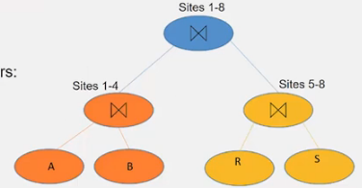

* 1. Inter-operator parallelism = each operator may run concurrently on a different site (exploits pipeline)
  2. Inter-query parallelism = different queries run on different sites

1. NoSQL Database Systems (**UNIT 9 START**)
   1. Until late 1990/early 2000s SQL was the most popular database system but the rise of web 2.0 the semantic web and social media applications triggered the start of NoSQL in 1998
   2. NoSQL Disadvantages:
      1. Does not full support relational features
         1. No join, group by, order by operations
         2. No referential integrity constraints across partitions
      2. No declarative query language (some efforts to define declarative language recently)
      3. Relaxed ACID -> fewer guarantees
         1. Atomicity = either whole process is done or none is done
         2. Consistency = only valid data is written
         3. Isolation = one operation at a time
         4. Durability = once committed, stays that way
         5. Hard to achieve and not always necessary
      4. No easy integration with other applications that support SQL
   3. NoSQL Advantages
      1. lot of apps do not need ACID properties but care more about:
         1. availability
         2. scalability
         3. Fault Tolerance
         4. Manageability
   4. Examples of NoSQL – no real standards for NoSQL DBMS – classifications based on data model used
      1. Key-value stores = stores data as set of key and value pairs – highly partitionable and allow for scaling for high velocity, non-transactional data (**UNIT 9 CONT’D**)
         1. Example = Amazon Dynamo DB (which is back-end)
            1. Query model:

Simple read/write operations with unique IDS

No operation spans multiple records

Data Stored as binary objects of small size

* + - * 1. ACID Properties – weaker with eventual consistency
        2. Efficiency = optimized for the 99.9th percentile
        3. Service Level Agreement

Cloud-computing and virtual hosting contracts include SLAs

Most are described in terms of mean, median, and variance response times and suffer from outliers

* + - * 1. Design decisions

Incremental scalability – must be able to add nodes on-demand with minimal impact

Load balancing

Replication – when?

Solve on write to reduce read complexity

Solve on read and reduce write complexity

Dynamo is an “always writable” data store

“highly write available”

Not included as a schemaless DB as so simple

Fine for shopping carts and such services

Who?

Data store and User Application

* + - * 1. System Interface – just two function

Put(key, context, object) get(key)

Key: primary key associated with data object

Context: vector clock and history (needed for merging)

Object: data to store

Partitioning and Replication

Use consistent hashing =

Each node gets an ID from the space of keys

Nodes are arranged in a ring

Data stored in the first node clockwise of the current placement of the data key

Replication

Preference lists of N nodes following the associated node

* + - * 1. Data Versioning

Updates generate a new timestamp

Eventual consistency – multiple versions of object may exist

Syntactic reconciliation – sys might resolve conflict automatic

Semantic reconciliation – conflict resolution pushed to app

* + 1. Document-based = stores as a document collection (JSON) (**UNIT 9 CONT’D**) e.g., MongoDB
       1. Take place of unsuccessful object-based DBs
       2. Data is stored as a collection of documents with no real schema
          1. Each document does not need to have same attributes of other documents
       3. Documents = documents that are exchanged across the internet e.g., JSON documents which have a ‘loose” or “semi-structured” structure

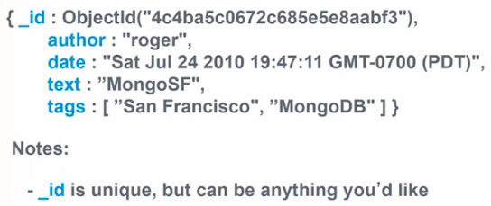

* + - * 1. JSON has a powerful but limited set of datatypes – Mongo extends datatypes with date, Int types, ID, . . .
        2. MongoDB stores data in BSON which is a binary representation of JSON

Optimized for performance and navigational abilities and compression

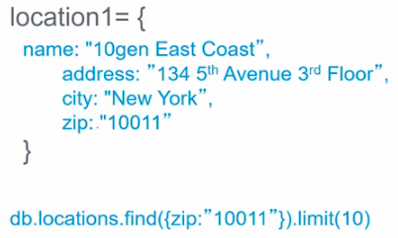

* + - * 1. Same queries but on JSON/BSON documents without joins as no integrity constraints without separate retrievals then unions/joins afterward
      1. Requirements:
         1. Locations:

Need to store locations (Offices, Restaurants, etc)

Want to be able to store name and address tags

Maybe generate content, i.e. tips or small notes?

Want to be able to find other locations nearby

* + - * 1. Checkins

User should be able to “check in” to a location

Want to be able to generate statistics

* + - 1. Unsharded Deployment – similar to master and set of slaves that are replicas
         1. Configure as a replica set for automated failover
         2. Async replication between nodes
         3. Add more secondaries to scale reads
      2. Sharded Deployment – multiple nodes in cluster and each has different partitions holding different atomic documents
         1. Autosharding distributes data among two or more replica sets
         2. Mongo Config server(s) handle distribution and balancing
         3. Transparent applications
      3. DocumentDB Advantages
         1. Documents are independent units

Makes performance better as related data is read contiguously off disk

Makes it easier to distribute data across multiple servers while preserving its locality

* + - * 1. Application logic is easier to write

Do not have to translate between objects in your application and SQL queries

Just turn the object model into a document

* + - * 1. Unstructured data can be stored easily and digested quickly

A document contains whatever keys and values the application logic requires

* + - 1. Disadvantages
         1. Cannot due joins
         2. No referential integrity
         3. 98% of DBs in World run SQL so not easy to integrate
    1. Column-Family-based = stores as row ID, column ID, timestamp, and value e.g. Google Big table, Casandra
       1. Still have row representation but not as rigid as relational
       2. Big distributed hash map table accessed by row, column, timestamp
          1. Arbitrary columns on row-by-row basis
          2. Does support relational model = no multi-row transactions
       3. Chubby lock service
       4. Follows traditional distributed architecture
       5. SSTable = immutable data structure with chunks of data
       6. Tablet – contains range of rows – built out of multiple SSTables
          1. Multiple tablets make up table
       7. Servers manage multiple tablets
       8. Not every row has an equal number of columns
    2. Graph-based = stores data as a graph, e.g. social graph/road network/brain graph of nodes/vertices and edges (**UNIT 9 CONT’D**)
       1. Social Network: persons, Friends, Photos
          1. Queries:

Find Alice’ friend

How Alice and Ed are connected

Find Alices’s photos with friends

Either returns a path or pattern in the graph (select-traverse-join)

Declarative query starts at first node such as Alice in “Alice-Tags-Photo” then does breadth-first search

Traverse/expand to other nodes

Join sometimes

Done via finite state machine

On distribute Communication libraries and Execution Engines who all send messages of current state to each other via Query Coordinator

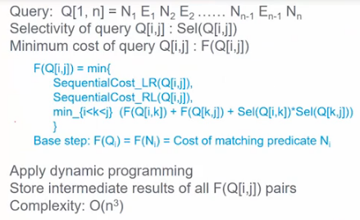

Dynamic programming = stores parts of BFS or DFS so it can be used over again

* + - * 1. Edges and nodes can have different types like follows and tagged
        2. Attributed multi-graph: Neo4j, Apache Titan, RDF (simplified), SparQl
        3. Graph Computation Engines for shortest path or page rank: Google Pregel (Giraffe), Apache Spark graph library Graphix
      1. Road Network
      2. Variable Column Model = not have a column for every property so just use graph

1. Scalability = add more resources
   1. Scaling Up or Vertical Scaling = get a bigger machine
   2. Scaling Out or Horizontal Scaling = get more small machines (ACID properties hard to achieve)
   3. Master/Slave Architecture = slaves are replicas of the master
      1. Whenever writes added to master they will be propagated to slaves when it finds time
         1. Either lazily or eagerly depending on system approach used
   4. Sharding or Partitioning Architecture = dated is sharded or partitioned across multiple nodes
      1. Like peer-to-peer as no master and slave
      2. Scales well for both reads and writes as can run on multiple machines (no multiple replicas to update)
      3. Distributed query processing is challenging because you may have to retrieve data that exists on multiple node
2. CAP theorem – for distributed systems on multiple nodes – rule of thumb = **you can only achieve two of the three properties at a time** as if you have partitions and have network failure you cannot assure consistency
   1. Consistency = all copies have same value } either have to have user wait
   2. Availability = reads and writes always succeed } or sacrifice consistency unless system NEVER fails
   3. Partition Tolerance = system properties hold even through failures preventing machine communication
   4. Strong Consistency = ACID Properties
   5. Weak Consistency = BASE = Basically Available Soft-State Eventual Consistency
      1. Write on one node and have conflict resolution for availability
      2. When no updates occur for a long time eventually all updates will propagate through the system and all the nodes will be consistent
3. NoSQL vs. SQL (**UNIT 10 START**) summary = allows you to sacrifice the ACID Properties for eventual consist
   1. Key value is separate as it is a more primitive data structure
      1. Pros
         1. Very fast as everything is retrieved from a key that is hashed
         2. Very scalable as no rigid schema and non-rigid consistency
         3. Simple model = easy to program
         4. Abel to distribute horizontally – simply add machines
      2. Cons
         1. Many data structures (objects) cannot be easily modeled as key value pairs
   2. Documents based, Column-based, and Graph-based are “schemaless” comparatively to relational
      1. Pros
         1. Schemaless data model is richer than key/value pairs (but not as much as relational)
            1. Eventual consistency
            2. Many are distributed
            3. Still provides excellent performance and scalability
      2. Cons
         1. Typically no ACID transactions or joins (same for key value stores)
      3. There have been efforts to bridge schemaless and key value
         1. No one-size fits all
   3. So you are giving up
      1. Joins (no referential integrity because no schema)
      2. Group by
      3. Order by
      4. ACID transactions (big issue if you need accuracy)
      5. SQL is sometimes frustrating but still powerful query language
      6. Easy integration with other applications that support SQL (and there are a lot)
4. Data Management in MapReduce Systems (**UNIT 11 START**) concept created by Google in early-to-mid-2000s to power search then Yahoo created open source MapReduce system called Hadoop
   1. Hadoop MapReduce for partitioned data in a parallelized framework = process of taking a list of objects and running some operation over each object in the list (Map phase) to either produce a new list or calculate a single value (Reduce phase). Hadoop parallel computing systems use MapReduce to run models over large distributed sets of data (Google used MapReduce to index the Internet)
      1. Phases are sent to all nodes in the cluster and each node can be a mapper or a reducer but does not have to be
      2. Master Node = one machine with master process that keeps track of the MapReduce programs written by users and all nodes and decides which machine runs what (Map Phase)
         1. Each worker will load part of the data and run same exact Map code on that data
         2. This Map Phase is massively parallelized across the cluster
         3. Stores the results on disk on the machine it runs on
      3. Data Shuffle Phase is a hidden phase between the Map and Reduce Phases and sorts out the data and moves it among the cluster before the reducers start work on it

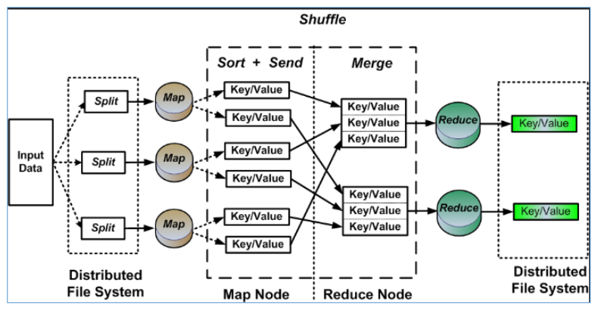

1. Two main components in Hadoop System:
   1. Distributed File System (HDFS) = primary data storage system used by Hadoop applications
      1. Single namespace for entire cluster
      2. Replicates data 3x for fault-tolerance
      3. Employes NHameNode and DataNode architecture to implement across highly scalable clusters
      4. Files split into 128MB blocks
         1. Replicated across several (3) data nodes
         2. Most are DataNodes but NameNode stores metadata about where data is stored
         3. Optimized for large files and sequential reads
         4. Files are append-only cannot update
   2. MapReduce Framework (see XXIV above for how this works)
      1. Executes user jobs specified as “map” and “reduce” functions
      2. Manages work distribution and fault-tolerance
      3. Written in Java and manages what machine is mapper or reducer
         1. Data Type – key value records allows almost anything to be a record
         2. Map Function – output has to be a list of key value pairs because reduce phase expects
            1. What key value pairs represent is up to developer
         3. Reduce Function
            1. Takes key value pairs as input and developer decides what function to apply
      4. Visualization – Map Phase on top/Shuffle in middle/Reduce Phase on bottom

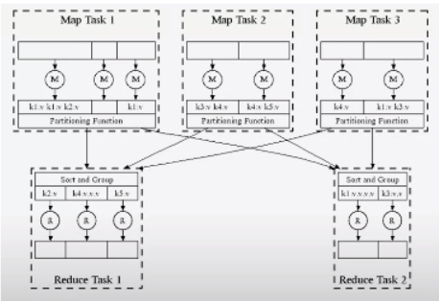 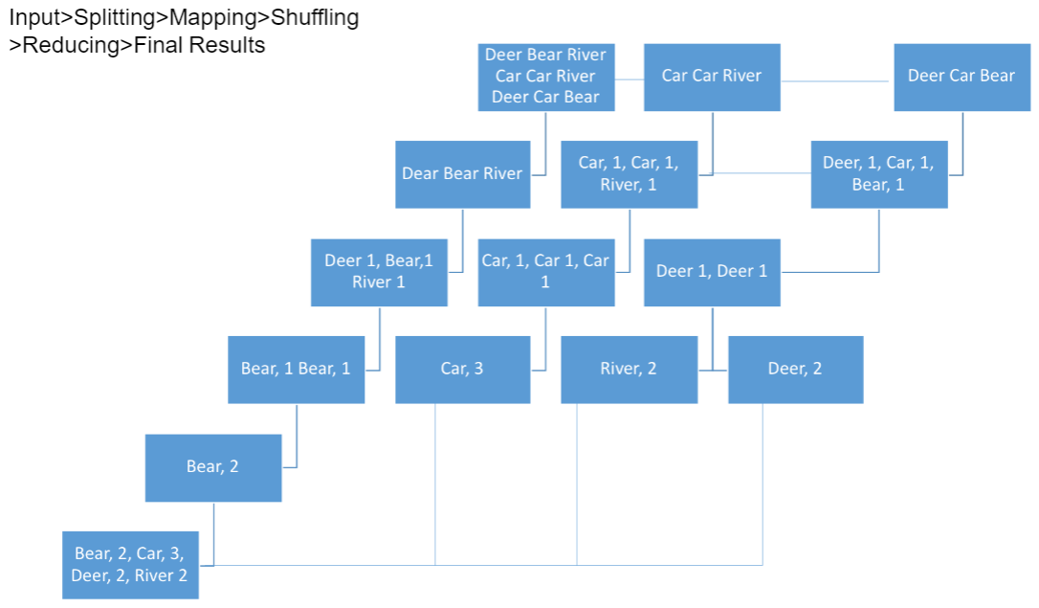

* + 1. Map counts how many times individual words appear (for example on whole WWW)
       1. Key = string representing word and value = count (1 for if word found)
       2. Partitioned by key
       3. Mappers are preferentially placed on same node or same rack as their input block to minimize network use
       4. Mappers save outputs to local disk before serving to reducers
          1. Allows having more reducers
          2. Allows recovery if a reducer crashes
    2. Key and list of values send to reducers who run in parallel and independent of each other
       1. Partition of key value pairs go to reduce and are combined
    3. Fault tolerance in Hadoop
       1. If task crashes
          1. Retry on another node
          2. OK for a map because it had no dependencies
          3. OK for reduce because maps outputs are on disk
       2. If same task repeatedly fails, fail the job
       3. If node crashes
          1. Re-launch its current task on other nodes
          2. Re-launch any maps the node previously ran

Necessary because their output files were lost along with the crashed node

* + 1. How do Operations Run in MapReduce
       1. Select Operator – if task is simple you do not even need a reduce phase
          1. Example map all rows that have ratings > 8 = once mapped you are done
       2. Projection Operator = select only a view columns – again reduce phase not needed
       3. Sorting Operator = done in shuffling phase
       4. Group By Operator = read blocks with key and value the Reduce Phase needed to count the group by aggregates
       5. Join Operator = need to figure out the key output value of the join operation (join key + value of tuple or whole row) so if that is figured during Map Phase then easy as all Reduce Phase has to do is check list of values from various tables

1. Apache Spark Resilient Distributed Dataset (RDD) (**START UNIT 12**) = fault-tolerant collection of elements
   1. An RDD is a read-only, partitioned collection of records – so you must have a shared-nothing cluster
   2. RDDs can only be created through operations on either:
      1. data in stable storage or
      2. other RDDs – all RDDS are created from another RDD – data loaded into RDD -> another RDD
   3. It is a restricted Distributed shared – memory System = RDD is distributed and shared in cluster memory
   4. RDD Contains:
      1. A set of partitions: atomic pieces of the dataset
      2. A set of dependencies on parent RDDs for fault tolerance
         1. RDDs remember how they are created so they can recreate themselves if crash
      3. A function for computing the dataset based on its parents for fault tolerance
         1. RDDs remember how they are created so they can recreate themselves if crash
         2. Parent RDDs and what operations where applied to generate child RDD
      4. Metadata about its partitioning scheme and data placement
   5. Two important features of RDD
      1. Fault tolerance achieved through lineage retrieval
      2. Lazy Evaluation = RDD will not be created until a reduced-like job or persistent job is called
   6. RDD Operations
      1. Transformations – include map, filter, join (each of these generate new RDD)
         1. Lazy Operation
      2. Actions – include count, collect, save (return a value or save results to disk)
         1. Triggers execution is why they are called actions
      3. Here filter is a transformation and count is an action

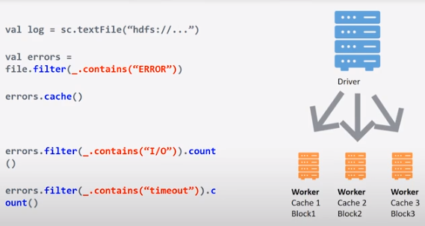

* + - 1. Filter RDD contains errors from loading data from Hadoop RDD
  1. Apache Spark build Directed Acyclic Graph (DAG) that shows logical view of execution or sequence of operations

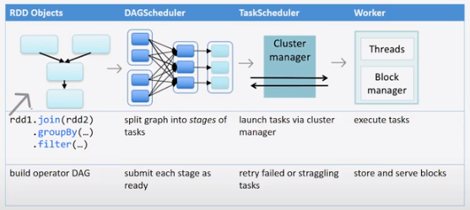

* + 1. Goes to DAG Scheduler that calculates with Cluster Manager how tasks get executed with goal of reducing the amount of data shuffle
       1. Narrow Dependency = transformation output needs input from only one partition
          1. Union = narrow dependency
       2. Wide Dependency = transformation output needs input from > 1 partition which leads to shuffling
          1. Join = wide dependency if join records are not copartitioned
          2. DAG scheduler tries to push wide dependencies later in process

1. Comparing Spark and Hadoop
   1. Spark:
      1. Has advanced DAG execution engine
      2. Supports in-memory cluster computing thanks to RDD
      3. Rich Data Processing API with map, filter, reduce, join, . . .
      4. Does not have its own storage system, but runs on myriad of storage engines such as HDFS, Cassandra, HBase, S3, . . .
   2. Hadoop:
      1. Only supports two runtime phases: Map and Reduce + hidden Data Shuffle Phase
      2. Intermediate data has to be on disk in HDFS in order to achieve fault tolerance
      3. Everything is programmed using Map/Reduce
      4. Loads data from HDFS
      5. Can be less expensive if you are not only worried about run time (less RAM)
2. Spark Ecosystem has Java, Scala, and Python APIs (execution run-times all the same) – libraries:
   1. Spark SQL – allows SQL-like queries on data via Data Frame
   2. Spark streaming – allows execution of streaming data – processing in real time (others are batch)
      1. Run a streaming computation as a series of very small, deterministic batch jobs - DStream
         1. Chop up live stream into batches of X seconds – as low as a half second with latency ~ 1
            1. Stream can come from many places including Apache’s Kafka stream consumption engine or a TCP socket connections
            2. Stateful Operations such as window for a time window in which to count the number of records or find first or last record in the window
            3. Output operations – same as RDD
         2. Spark treats each batch as RDDs and processes them using RDD operations
         3. Finally, the processed results of the RDD operations are returned in batches
         4. Potential for coming batch processing and streaming processing in the same system
         5. Fault tolerance maintained
         6. Smart Streaming Reduce – incrementally computes count generalizes to many reduce operations
   3. MLib for machine learning – provides support for main machine learning algorithms
   4. GraphX for graphs – provides vertices and edges (page rank used for search is a graph algorithm)
3. Common Components of Apache Hadoop Ecosystem
   1. Apache Hive = data warehouse infrastructure that provides data summarization and ad hoc querying
      1. For using SQL-like operations to interact with data warehouses rather than MapReduce
      2. Business analytics and statistics can be run by people comfortable with SQL
      3. Hive Query Language = HiveQL does not run on a SQL engine but rather are converted to MapReduce
   2. Apache Pig = high-level data-flow language and execution framework for parallel computation
      1. Processes data flow programs on top of Hadoop
      2. Pig Latin language => optimized and turned into MapReduce
   3. Apache HBase = scalable, distributed database that supports structured data storage for large tables
      1. NoSQL database based on Google Big Table Idea on top of Hadoop
   4. Apache Zookeeper = high-performance coordination service for distributed architecture
      1. Configuration or synchronization service for Hadoop – originally part of Hadoop no independent
   5. Many more projects built on top of Hadoop to perform specific tasks – all build on MapReduce
      1. Apache Mahout – originally on top of Hadoop for machine learning but now not MapRaduce but rather assisted call Apache Spark
4. GeoSpark for Large Scale Spatial Data in cluster data platform Apache Spark
   1. Takes RDD layer and extends it with spatial data processing geometrical operations
      1. Spatial RDDS = line, point or polygon
      2. Automated partitioning of proximate data and building indices for each partition
      3. Range querys are all objects in rectangle or polygon
      4. User runs spatial query using either RDD API in Apache Spark or SQL API and use data frame abstraction
   2. Spatial Partitioning and Querie
      1. Simplest way to partition geospatial data is to impose a uniform grid on the RDD = not scalable due to skew and load balancing problem but very efficient for evenly distributed data
      2. Other way is to assign quad tree or R-tree or KDB tree partitions based on density
      3. Can built a spatial index for each local partition – this overhead only worth it is repeated querys
      4. Spatial Range Query – defined with ST-Contains[bound, value]
      5. Spatial KNN Query – requires mor computation as not sure how far neighbors are so incrementally increase circle until you find K number of neighbors
      6. Spatial Join – if both table no copartitioned based on proximity you will need to do a lot of shuffling – but if copartitioned on proximity then can run way faster with less shuffle
      7. Query Optimizer – start with SQL query and a dataframe the it does logical optimization
      8. Heuristics based optimization
         1. Predicate Pushdown = rage on two table then join
         2. Predicate Merging = when two polygons overlap and you have an AND you do a ST_Contains on overlap and if you have an OR you ST-Contains union of the two
      9. Spatial Join Query – Apache Spark is WAY faster but uses more memory than Hadoop
5. Optimization for Spatial SQL Queries – indexing requires converting data from 2 or 3 dimensions to 1
   1. Space filling curves = take mathematical property of 2D data and map each 2D cell with 1 number and the amount of cells represent how close they are in space
      1. Compromise = 1D representation may lose a lot of detail of the spatial data
   2. Natively optimized spatial indices instead of converting to one dimension
      1. Similar indices to B-Trees and Hash Tables available for spatial data
         1. Quad Tree – start partitioning to 4 quadrants and keep doing so based on data
         2. R-Tree – does not partition space but rather partitions data and finds minimum bounding rectangles for data clustered in the same location
         3. Voronoi Diagram – partitions cells based on math theory such that the points within the cells are the closest
6. Scalable Data Processing in the Cloud (**START UNIT 13**)
   1. Cloud = model for enabling ubiquitous, convenient, on-demand network access to a shared pool of configurable computing resources that can be rapidly provisioned and released with minimal management effort or service provider interaction. 5 Essential Characteristics include:
      1. On-Demand Self-Service for server time or network storage as needed automatically
      2. Broad Network Access – via standard mechanisms including thick or thin (less software) client platforms
      3. Resource Pooling – among multiple consumers (consolidation) using a multi-tenant model with dynamic assignment according to consumer demand and location independence (transparency)
      4. Rapid Elasticity – outward and inward elastic provisioning and release
      5. Measured Service – automatic control and optimization by leveraging appropriate types of service
   2. Types of cloud computing Service Models (optional) (**UNIT 13 CONT’D**)
      1. Infrastructure as a Service (IaaS)
         1. Capability provided to consumer – provisioning of resources (Xen-based VMs) and deployment of software – consumer does not manage or control underlying infrastructure but has control over OS, storage, deployed applications
      2. Platform as a Service (PaaS)
         1. Capability provided by consumer to deploy on cloud or acquire applications created by programming languages, library services, or tools supported by the provider – consumer does not mange or control underlying cloud infrastructure but does control over deployed applications
         2. E.G. Google App Engine – supports apps written in variety of languages with auto scaling
      3. Software as a Service (SaaS) – nothing but applications provided to consumer and available through various client devices – consumer does not manage or control underlying infrastructure with possible exception of limited user-specific application configuration settings
      4. X as a Service – involves Storage (Drop Box), Big-Data (Amazon MapReduce), Database (Azure SQL), Bare-Metal (softLayer) – each as a Service
   3. Cloud Deployment Models = alternative way to view cloud services (**UNIT 13 CONT’D**)
      1. Public Cloud – provisioned for open use by general public – owned, managed, and operated by business, academic, government organization or a combination
      2. Private Cloud – provisioned for exclusive use by a single organization – owned, managed, and operated by an organization, third party (Amazon and IBM build and manage private clouds), or a combination – exists on or off premises of organization
      3. Hybrid Cloud – combination of public and private cloud – bound together by standardized or proprietary technology that enables data and application portability (cloud bursting = balancing between clouds)
7. Introduction to Amazon Web Services (AWS) (**UNIT 13 CONT’D**)

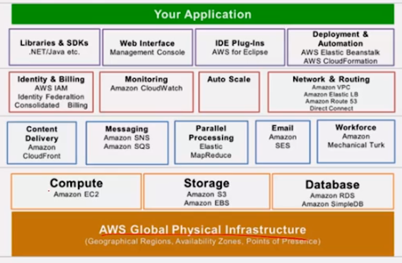

* 1. Compute – Elastic Cloud Computing (ECC or EC2)
     1. Virtual computing environments = instances = virtual machines
        1. Preconfigured templates for instances = Amazon machine Images (AMI) = image stored in S3 that serves as root device for images to make virtual machines
           1. Multiple and different types of instances can be created from the same AMI

These instances cannot make a permanent change to the image

* + - * 1. You can create your own custom AMIs
        2. Instance store-backed root device does not persist unless you save it on EBS

Root Device Volume can be backed by the instance store or EBS which can be expensive

* + - 1. Different types with various configurations of CPU, memory, storage, and network capacity
      2. Multiple physical locations for running instances with regions and availability zones
    1. Instance Lifecycle
       1. You stop incurring charges as soon as its state changes to stopping
       2. Each time an instance transitions from stopped to pending, we start a new instance billing hour
       3. Instance gets a private IP address and an internal DNS hostname which is useful for communications within the cloud network
       4. Instance also gets a public IP and an external DNS hostname
          1. NAT = automatically mapped to the private IP address through network address translation
          2. Non-persistent = automatically released when the instance is stopped or terminated
          3. Elastic IP address (EIP) is a public IP that you can allocate to your account

Can be associated to an instance and persist

But you will be charged if your EIP is associated with a running instance

First EIP is associated with a running instance for free – additional ones will be charged

* 1. Storage
     1. Elastic Block Storage (EBS)
        1. Reliable block-level storage automatically replicated within availability zone
        2. Can persist independently from instances
        3. Can be attached/detached to/from any instance
        4. Multiple volumes can be attached to a single instance
        5. Snapshots
           1. Can back up an EBS volume by taking snapshots which are stored in S3
           2. Snapshot stores only the changes to the volume since the previous snapshot
        6. You can create new EBS volumes from the snapshot
     2. Simple Storage Service (S3) = reliable, inexpensive general purpose object store with high durability due to data being stored across multiple facilities and multiple devices in each facility
        1. More reliable than EBS
        2. Stores AMIs, EBS volume snapshots, or any data
        3. Data is stored as objects within buckets
           1. Access control can be assigned to each bucket
           2. Each object has a unique key and is accessed using HTTP URLs
  2. Messaging
     1. AWS Queueing – Simple Queue Service (SQS)
        1. Makes it simple and cost-effective to decouple the components of a cloud application by acting as buffer between producers and consumers
           1. Messages can contain up to 256k of text in any format
           2. Ensures delivery of every message at least once
           3. Supports multiple readers and writers working on same queue concurrently
     2. Simple Notification Service (SNS)
  3. Database
     1. Simple DB
     2. RDS
  4. AWS Programming Interfaces = unified tool for managing AWS service – Windows, Linux, OS X, Unix
     1. Suggested to create and IAM for user using the command lines
  5. Autoscaling – ability to grow or shrink = elasticity = great feature of cloud
     1. Acquire cloud resources on-demand
     2. Make efficient use of rented resources
     3. Relinquish unneeded resource in timely manner
     4. AWS auto scaling resources
        1. Uses CloudWatch to monitor utilization
        2. Trigger scaling when utilization is high
        3. Create new instances to handle load
        4. Use Elastic Load Balancing to distribute load across instances
     5. Scaling based on SQS = more sophisticated autoscaling control
        1. SQS queues the requests received by web server and be processed by the processing servers
        2. Use length of the queue to determine the load and decide auto scaling
  6. Scalable Data Processing
     1. Overall Process
        1. Work Queue – gathers processing jobs
        2. Job Launcher – sends to EC2 provision system then to Hadoop cluster
        3. Data Collection Process – is separate and done by other software => sends data to Hadoop cluster
        4. S3 Output Bucket receives output from Hadoop cluster => user front end web server
     2. Example GrepTheWeb
        1. Regular expression against massive amount of web documents
        2. Challenges:
           1. Regular expressions could be complex
           2. Dataset could be large
           3. Unknown request patterns
        3. High-Level Architecture:

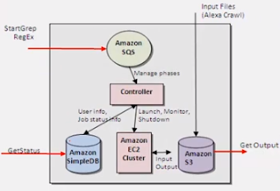

* + - * 1. S3 for retrieving input datasets ad for storing the output dataset
        2. SQS for durably buffering requests acting as a “glue” between controllers
        3. Simple DB for storing intermediate status, log, and for user data about task
        4. EC2 for running large distributed processing Hadoop cluster on-demand
        5. Hadoop for distributed processing, automatic parallelization, and job scheduling
      1. Workflow
         1. Launch – upon user request

Update status of SimpleDB, start EC2 instances, start MapReduce

* + - * 1. Monitor – check Hadoop status periodically
        2. Shutdown – execute shutdown task

Kill Hadoop processes, terminate EC2 instances

Billing task calculates billing

* + - * 1. Cleanup – archive SimpleDB data
      1. Detailed architecture

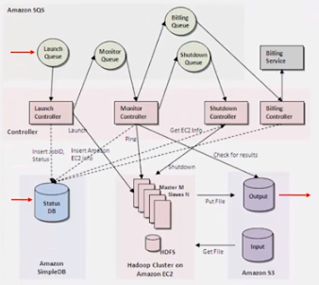

* + - 1. How EC2 was used?
         1. All controllers run on EC2 instances
         2. The master and slave instances for Hadoop – launched from preconfigured AMI
      2. How was S3 used?
         1. Input

The web documents stored in S3

Huge (in terabytes) and always growing

* + - * 1. Output – the grep results
      1. How was SQS used?
         1. Buffer

Bridge the speed difference between sender and receiver

Decouple sender and receiver and smooth out bursty traffic

* + - * 1. Isolation

Make entire system loosely coupled

Provide uniform way of transferring information between different components

No component directly calls another component

* + - * 1. Asynchrony

One slow or failing component does not affect any other component

Makes entire system stable and available

* + - 1. How was SimpleDB used?
         1. Track state of the system

SimpleDB is schema-less; every controller can define its own structure and append data to a “job” item

Launch controller adds/updates “launch_status”

Monitor controller adds/updates “monitor_status” and “Hadoop_status”

Any component can query Simple DB at any time

* + - * 1. Store active Request IDs for historical and auditing/billing purposes

1. What is Hadoop? – open source software project to manage large datasets via clusters and parallelization
2. What is AWS Security?
   1. Security credentials are required to access EC2 using command line tools and API
   2. EC2 key pairs
      1. Public key used to encrypt a piece of data
      2. Private key used to decrypt the data
      3. Create key pair using EC2, or upload your own key pai
      4. Lose your private key = involved process to connect to your instance
   3. AWS Identity and Access management (IAM) service
      1. Use IAM to allow other users, services, and applications to use your EC2 resources
      2. Do not use your AWS root account for day-to-day interaction with AWS as it provides unrestricted access to your AWS resources
      3. Create users and groups under AWS account
      4. Assign unique security credentials to each user
      5. Control each user’s permissions to perform tasks
      6. Allow users in other AWS accounts to share your resources
      7. Create roles for your account and define users or services that can assume them
   4. Security Group = virtual firewall controlling access where you can add rules and block traffic to or from
      1. EC2 evaluates all rules when deciding who to allow
3. AWS Video
   1. Structured – MPP Databases and Amazon Redshift
      1. Massively Parallel Processing allows scalable standard SQL
      2. Shared nothing architecture = linear scaling effect
      3. Not good for transactional
      4. Redshift = MPP SQL Database – gigabytes to Petabytes
         1. Fully relational and fully managed
         2. Dramatically reduces I/O by allowing look at only certain columns
         3. Uses data compression after figuring out best compression algorithm to maximize data in block to speed up queries more than minimize disk space
         4. Zone maps act like a hash index
         5. Can take data from S3, DynamoDB, EMR, Linux
         6. ETL – Extract Transport Load facilitate regular DBs into Redshift
   2. Unstructured – Hadoop and Amazon EMR
      1. Input files and function get loaded to cluster and Hadoop figures out what to do
      2. Elastic Map Reduce – managed Hadoop service = managed spinning up instances
      3. Spot market gives discounts on available nodes for cluster
      4. Master instance – core instance – task instance group
   3. Streaming – real-time analysis and Amazon Kinesis
      1. Fully managed service for processing stream data – various applications do not interfere with each other such as S3, DynamoDB, Redshift, EMR
      2. As fast as every millisecond with 50KB payload for each shard and messages kept for 24 hours

ORPHAN LANGUAGE appears above but in different form

* 1. Participation Constraints, e.g. does every department have a manager? (why is this here?)
     1. If yes then then every did value in Departments entity must appear in a row of the Managers table with a non-null ssn value
     2. If you offer a tuple for Depart_Mgr table without ssn it is rejected
  2. Weak Entities – can be identified uniquely only by considering the primary key of another owner entity
     1. Owner entity set and weak entity set must participate in a one-to-many relationship set (one owner and many weak entities)
     2. Weak entity set must have total participation in this identifying relationship
     3. Weak and identifying relationship set are translated into a single table
     4. If owner is deleted then dependents also have to be deleted
  3. Class Hierarchies – ISA relationship = inheritance **(see also page 3)**
     1. Overlap Constraints must be allowed or disallowed
     2. Covering Constraints created by saying if multiple relationships allowed
     3. General Approach = generate 3 relations – might require join for just hourly employees
     4. Alternative Approach = if employee is only either hourly or salary just create two relations and each employee must be in one of these two subclasses

An "index-only plan" means that a **(non-clustered) index contains all the columns needed to answer the query without having to access the tuples in the base relation**. This gives a very efficient execution for two reasons: 1. it avoids the one disk I/O per tuple that is usually needed when

1. . NoSQL databases come in four core types — one for each type of data the database is expected to manage:

   * **Columnar:** Extension to traditional table structures. Supports variable sets of columns (column families) and is optimized for column‐wide operations (such as count, sum, and mean average).
   * **Key‐value:** A very simple structure. Sets of named keys and their value(s), typically an uninterpreted chunk of data. Sometimes that simple value may in fact be a JSON or binary document.
   * **Triple:** A single fact represented by three elements:
     + The subject you’re describing
     + The name of its property or relationship to another subject
     + The value — either an intrinsic value (such as an integer) or the unique ID of another subject (if it’s a relationship)

   For example, Adam likes Cheese. Adam is the subject, likes is the predicate, and Cheese is the object.

   * **Document:** XML (eXtensible Markup Language = like HTML), JSON (Java Script Object Notation), text, or binary blob. Any treelike structure can be represented as an XML or JSON document, including things such as an order that includes a delivery address, billing details, and a list of products and quantities.

   Some document NoSQL databases support storing a separate list (or document) of properties about the document, too.